**Data Structures**

Data Structures is all about How will you Structure your data, so that you can store fetch in efficient way.

Abstract Data Types

1. List
2. Queue 🡪FIFO
3. Stack 🡪LIFO
4. Map

* These are called as Abstract data types because they are just a concept every programming language has different implementation.

Arrays

* Arrays are simple to use and faster
* Arrays are fixed in size, we cannot be able to expand once it is declared.
* If we declared larze size of array memory is wasted.
* To solve this problem we need to use LikedList.

Linked List

* With liked list we can over come the problems in Array
* To make Sequence first of all you need to make first element as head
* Each element We can call as Node
* We need to create one more Node to Store the adress of the next Node.
* In the last element node null will be stored because ofter that we don’t have any Node.

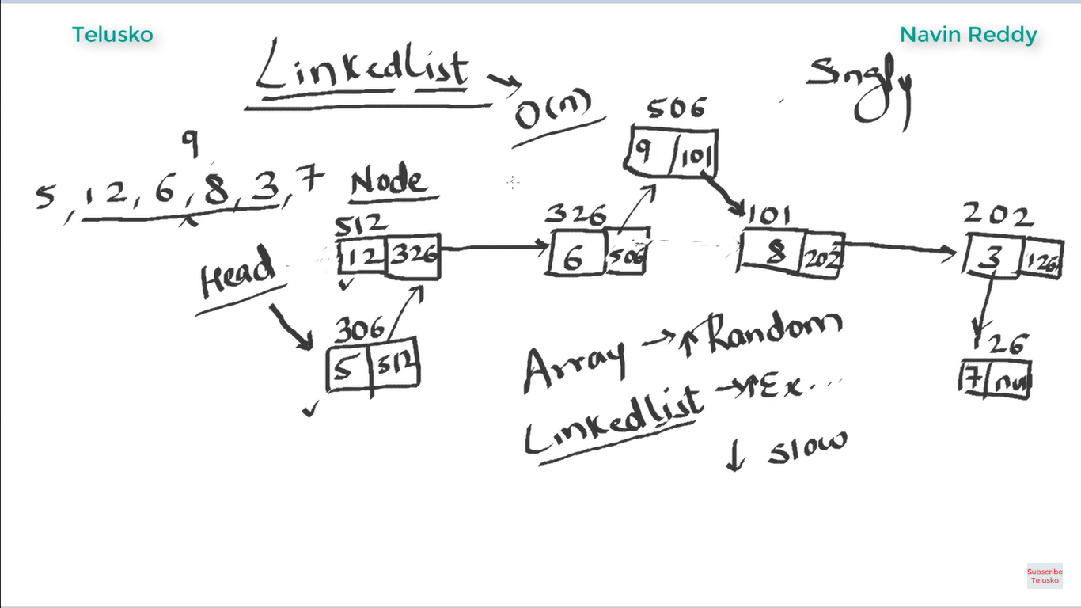

**Implementation:**

Step1: Create a simple java project with main method.

Step2:Then create a Node class which contains data of int type and Node class itself to store the adress of next node;

Step3: Create Onemore class called Linked this class for implenting all the fuunctions

Step4:Create object and call those methods in linked class from main method

public class App {

public static void main(String[] args) throws Exception {

Linked linked = new Linked();

linked.insert(2);

linked.insert(23);

linked.insert(25);

linked.insertAtHead(15);

linked.inserAtIndex(123, 1);

linked.removeAtIndex(1);

linked.show();

}

}

public class Node {

int data;

Node next;

}

public class Linked {

    Node head;

    public void insert(int data) {

        Node node = new Node();

        node.data = data;

        node.next = null; // this is the adress of the data right now we want to insert

        if (head == null) {

            head = node;

        } else {

            Node n = head; // temparay node which holds the adress of prevous node

            while (n.next != null) {

                n = n.next;

                // if reference adress of next node null means there is no next node, then

                // temparary node will hold the adress of current node

            }

            n.next = node;

            // if n.next is null means we are at the last node , so we need to store our

            // current value ofter the last node,always the last node is null,

            // and previously it was null and now it was replaced by the adress of the

            // current value we want to insert

        }

    }

    public void insertAtHead(int data) {

        Node node = new Node();

        node.data = data;

        node.next = null;

        node.next = head;

        head = node;

    }

    public void inserAtIndex(int data, int index) {

        Node node = new Node();

        node.data = data;

        node.next = null;

        Node n = head;

        if (index == 0) {

            insertAtHead(data);

        } else {

            for (int i = 0; i < index - 1; i++) {

                n = n.next;

            }

            node.next = n.next;

            n.next = node;

        }

    }

    public void removeAtIndex(int index) {

        Node n = head;

        Node n1 = null;

        for (int i = 0; i < index - 1; i++) {

            n = n.next;

        }

        n1 = n.next;

        n.next = n1.next;

    }

    public void show() {

        Node n = head;

        while (n.next != null) {

            System.out.println(n.data);

            n = n.next;

        }

        System.out.println(n.data);

    }

}

Stack

* Stack fallows LIFO pattern
* Features of stack are

1. Push 🡪 to add
2. Pop 🡪 to delete
3. Peak 🡪to find peak

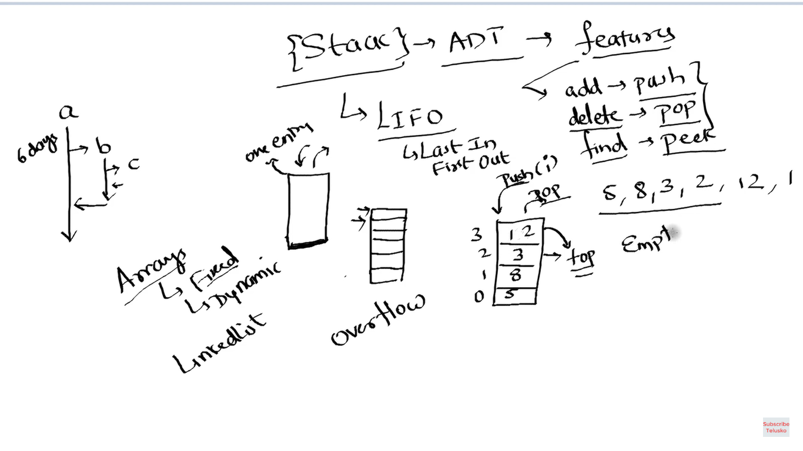

Step1:First we need create a Simple java project with main method

Step2:Then create class for create functions to Implement stack

public class App {

public static void main(String[] args) throws Exception {

Dstack cStack = new Dstack();

cStack.push(12);

cStack.push(13);

cStack.push(29);

cStack.push(3);

cStack.push(23);

cStack.pop();

cStack.show();

cStack.pop();

cStack.show();

}

}

public class Dstack {

int capacity = 2;

int stac[] = new int[capacity];

int top = 0;

public void push(int data) {

if (size() == capacity)

expand();

stac[top] = data;

top++;

}

public void expand() {

int length = size();

int newStack[] = new int[capacity * 2];

System.arraycopy(stac, 0, newStack, 0, length);

stac = newStack;

capacity *= 2;

}

public boolean isEmpty() {

if (top == 0) {

return true;

} else {

return false;

}

}

public int size() {

return top;

}

public void show() {

for (int i : stac) {

System.out.println(i);

}

}

public int pop() {

int data = 0;

if (isEmpty()) {

System.out.println("stack is empty");

} else {

top--;

data = stac[top];

stac[top] = 0;

shrink();

}

return data;

}

public void shrink() {

// To Reduduce the size of array when we use operation and the length of array

// is less than half of its capacity

int length = size();

System.out.println("length" + length);

if (length <= (capacity / 2) / 2)

capacity = capacity / 2;

System.out.println("capacity" + capacity);

int newStack[] = new int[capacity];

// we are create new array with size half of original array and copy data from

// original array to new arry

System.arraycopy(stac, 0, newStack, 0, length);

stac = newStack;

}

public void peak() {

top--;

}

}

Java program to create and display a Circular Linked List

In this program, we will create a circular linked list and print all the nodes present in the list.

Circular Linked List:

* The circular linked list is a kind of linked list. First thing first, the node is an element of the list, and it has two parts that are, data and next. Data represents the data stored in the node and next is the pointer that will point to next node. Head will point to the first element of the list, and tail will point to the last element in the list. In the simple linked list, all the nodes will point to their next element and tail will point to null.
* The circular linked list is the collection of nodes in which tail node also point back to head node. The diagram shown below depicts a circular linked list. Node A represents head and node D represents tail. So, in this list, A is pointing to B, B is pointing to C and C is pointing to D but what makes it circular is that node D is pointing back to node A.
* Java program to create and display a Circular Linked List
* **Algorithm**
* Define a Node class which represents a node in the list. It has two properties data and next which will point to the next node.
* Define another class for creating the circular linked list and it has two nodes: head and tail. It has two methods: add() and display() .
* add() will add the node to the list:
* It first checks whether the head is null, then it will insert the node as the head.
* Both head and tail will point to the newly added node.
* If the head is not null, the new node will be the new tail, and the new tail will point to the head as it is a circular linked list.
* display() will show all the nodes present in the list.
* Define a new node 'current' that will point to the head.
* Print current.data till current will points to head
* Current will point to the next node in the list in each iteration.

Program:

public class CreateList {

//Represents the node of list.

public class Node{

int data;

Node next;

public Node(int data) {

this.data = data;

}

}

//Declaring head and tail pointer as null.

public Node head = null;

public Node tail = null;

//This function will add the new node at the end of the list.

public void add(int data){

//Create new node

Node newNode = new Node(data);

//Checks if the list is empty.

if(head == null) {

//If list is empty, both head and tail would point to new node.

head = newNode;

tail = newNode;

newNode.next = head;

}

else {

//tail will point to new node.

tail.next = newNode;

//New node will become new tail.

tail = newNode;

//Since, it is circular linked list tail will point to head.

tail.next = head;

}

}

//Displays all the nodes in the list

public void display() {

Node current = head;

if(head == null) {

System.out.println("List is empty");

}

else {

System.out.println("Nodes of the circular linked list: ");

do{

//Prints each node by incrementing pointer.

System.out.print(" "+ current.data);

current = current.next;

}while(current != head);

System.out.println();

}

}

public static void main(String[] args) {

CreateList cl = new CreateList();

//Adds data to the list

cl.add(1);

cl.add(2);

cl.add(3);

cl.add(4);

//Displays all the nodes present in the list

cl.display();

}

}

Output:

Nodes of the circular linked list:

1 2 3 4

Doubly Linked List

Step1:create a main class and create an object for linkedlist class.

public class App {

    public static void main(String[] args) throws Exception {

        Linked li = new Linked();

        li.insertData(10);

        li.insertData(16);

        li.insertData(12);

        li.insertData(14);

        li.insertData(16);

        li.insertAtStart(1);

        li.insertAtEnd(99);

        li.insertAtEnd(100);

        li.insertAtPosition(5, 176);

        li.deleteAtBeg();

        li.deleteAtPosition(1);

        li.deleteAtEnd();

        li.show();

    }

}

Step2:create class for Node

public class Node {

    int data;

    Node next;

    Node prev;

}

Step3:create Linked class

public class Linked {

    Node head = null;

    Node tail = null;

    public void insertData(int data) {

        Node node = new Node();

        node.data = data;

        node.next = null;

        node.prev = null; // this is the adress of the data right now we want to insert

        if (head == null) {

            head = node;

            tail = node;

        } else {

            Node n = head;

            while (n.next != null) {

                n = n.next;

            }

            n.next = node;

            n.prev = n;

            tail.next = node;

            tail = n.next;

        }

    }

    public void insertAtStart(int data) {

        Node node = new Node();

        node.data = data;

        node.next = null;

        node.next = head;

        tail = node.next;

        node.prev = null;

        head = node;

    }

    public void insertAtEnd(int data) {

        Node node = new Node();

        node.data = data;

        node.prev = tail;

        tail.next = node;

        tail = node;

    }

    public void insertAtPosition(int index, int data) {

        Node node = new Node();

        node.data = data;

        node.next = null;

        Node temp = head;

        for (int i = 0; i < index - 1; i++) {

            temp = temp.next;

        }

        node.next = temp.next;

        node.prev = temp;

        temp.next = node;

    }

    public void deleteAtBeg() {

        Node temp = head;

        head = temp.next;

    }

    public void deleteAtPosition(int index) {

        Node n = head;

        Node n1 = null;

        for (int i = 0; i < index - 1; i++) {

            n = n.next;

        }

        n1 = n.next;

        n.next = n1.next;

        n.prev = n;

    }

    public void deleteAtEnd() {

        Node temp = head;

        Node temp2 = null;

        while (temp.next != null) {

            temp = temp.next;

        }

        temp2 = temp.prev;

        System.out.println("temp2" + temp);

        temp2.next = null;

        // Not working properly

    }

    public void show() {

        Node n = head;

        while (n.next != null) {

            System.out.println(n.data);

            n = n.next;

        }

        System.out.println(n.data);

    }

}

Alternate way to Circular Linked List

Step1:Create main class

public class App {

    public static void main(String[] args) {

        Linked linked = new Linked();

        linked.insertData(1);

        linked.insertData(2);

        linked.insertData(5);

        linked.insertData(7);

        linked.insertData(8);

        linked.insertData(9);

        linked.insertData(6);

        linked.insertAtIndex(4, 99);

        linked.deleteAtEnd();

        linked.removeAtIndex(1);

        linked.show();

    }

}

Step2:create Node class

public class Node {

    int data;

    Node next;

}

Step3:create Linked List

public class Linked {

    Node head = null;

    Node tail = null;

    public void insertData(int data) {

        Node new_node = new Node();

        new_node.data = data;

        new_node.next = null;

        if (head == null) {

            head = new_node;

            head.next = head;

        } else {

            Node n = head;

            while (n.next != head) {

                n = n.next;

            }

            n.next = new_node;

            new_node.next = head;

        }

    }

    public void insertAtIndex(int index, int data) {

        Node new_node = new Node();

        new_node.data = data;

        Node n = head;

        Node n1 = null;

        for (int i = 0; i < index - 1; i++) {

            n = n.next;

        }

        n1 = n.next;

        new_node.next = n1.next;

        n.next = new_node;

    }

    public void deleteAtEnd() {

        Node n = head;

        Node temp = null;

        while (n.next != head) {

            temp = n;

            n = n.next;

        }

        n = temp;

        n.next = head;

    }

    public void removeAtIndex(int index) {

        Node n = head;

        Node temp = null;

        for (int i = 0; i < index - 1; i++) {

            n = n.next;

        }

        temp = n.next;

        n.next = temp.next;

    }

    public void show() {

        Node temp = head;

        System.out.println(temp.data);

        while (temp.next != head) {

            temp = temp.next;

            System.out.println(temp.data);

        }

    }

}

Infix,Prefix and Post Fix

* To use this concept we need to fallow precedence rule

1. () {} []
2. ^ (power or square) precedence will be right to left
3. * / precedence will be left to right
4. + - precedence will be left to right

Postfix:

<operand><operator><operator>

Ex: 5+1 =>51+

a*b+c =>ab*+c

ab*c+

Prefix:

<operator><operand><operand>

5+1=>+51

a*b+c =>*ab+c

+*abc

Infix to PostFix Conversion

1) Print operands as they arrive

2) If stack is empty or contains a left paranthasis on top ,push the incoming operator on to the stack

3) If incoming symbol is ‘(‘ push it onto stack

4) If incoming symbol is ‘)’ pop the stack & prints the operaters until left paranthasis found

5) If incoming symbol is has higher precedence than the top of the stack,push on to the stack .

6) If incoming symbol has lower precedence than the top of the stack, pop & print the top.Then test the incoming operator against the new top of the stack.

7) If incoming operator has equal precedence with the top of the stack,use associative rule.

8) At the end of the expression,pop & print all operators of stack .

9)Associativity L to R then pop and print the top of the stack & and then push the incoming operator.

10) R to L then push the incoming operatior.

Evaluation of Prefix Expression

1) Scan prefix expression from right to left for each char in prefix expr

Do

If operand is there push it onto the stack else if operator is there ,pop 2 elements

Op1=top element

Op2=next to top element

Result= op1 operator op2

Push result into stack

Return stack [top]

Evaluation of Postfix Expression

1. In Post fix we need to start evaluate from left to right
2. In Post fix top of the stack is operand is operand2 and below the top element is operand 1 althogh for multiplication , addition and square it makes no difference but division and substraction it will make diffrence.

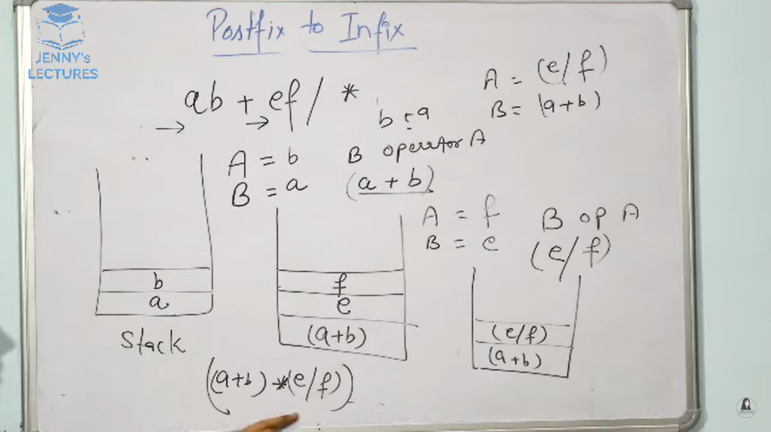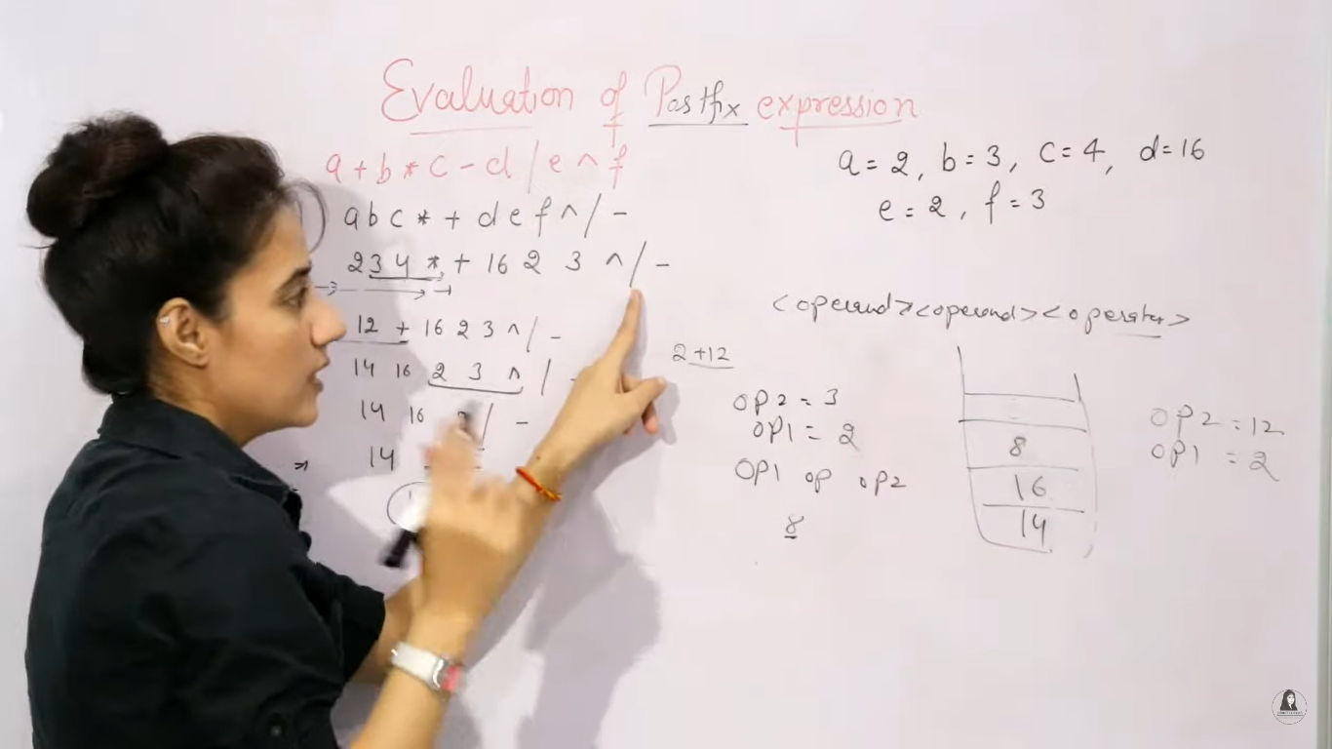

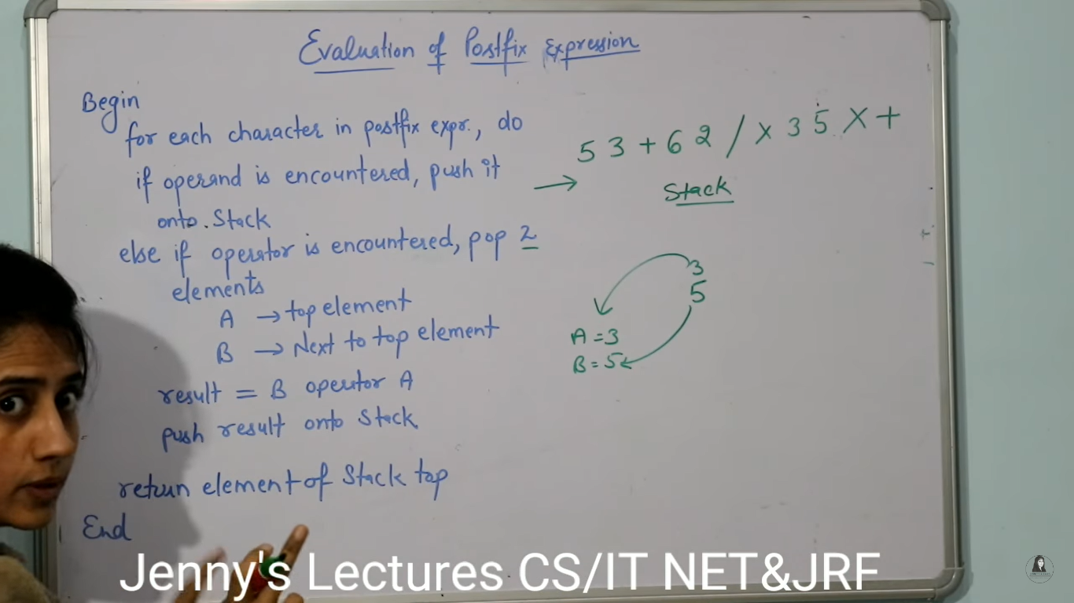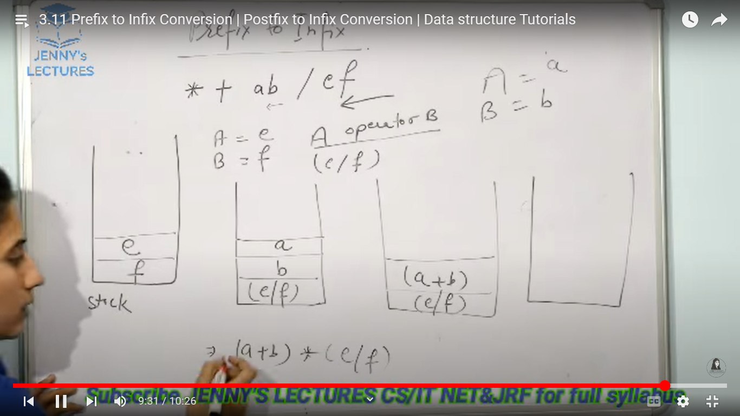

Binary Expression Trees

The Expression in the Form of a specific kind of binary Tree that is known as binary expression tree.

1. In this structures operands acts like leaves of tree or external nodes
2. Operators are assigned like internal nodes or roots of tree

Ex: a*b/c+e/f*g+k-x*y

1. In tree structure leaves would have higher precedence and roots will have least precedence

Step1:first we need find out root for this expression to do this we need scan the expression from left to right

Step2: so we need to find the lowest precedence in our expression the – operator bitween the lowset precedence because it is right most .

Step3: now we are find the root of our exression.

Step4:we need to divide the expression two parts from – operator.

Step4:apply the same rule to divide the remaing expression as tree.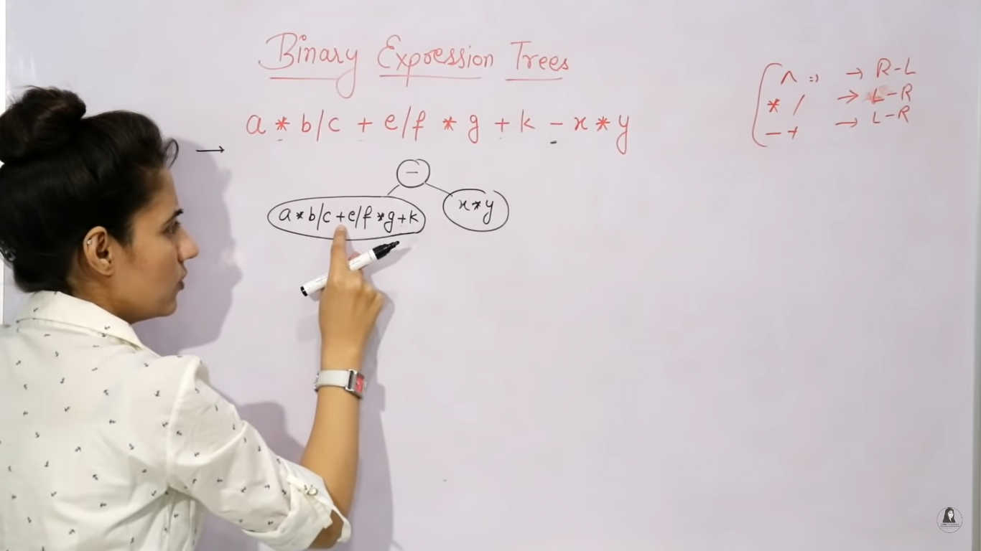

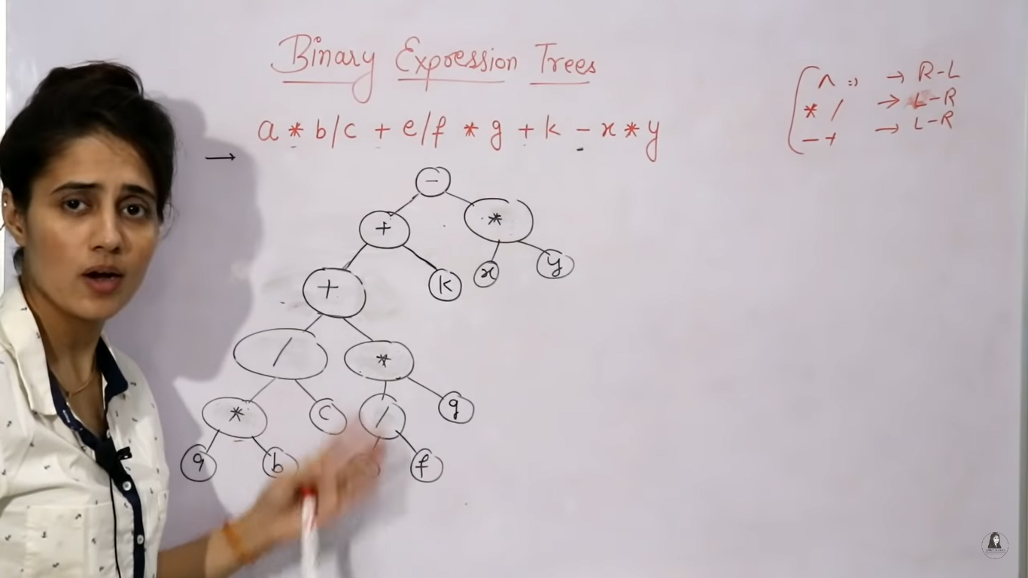

Step5:we can find postfix and prefix expression from this tree structure

Preorder:(root left right)

PostOrder:(left right Root)

Prefix for this - + + /*abc *efgk*xy

Postfix:ab*c/ef/g*+k+xy*-

Tree Structures

* Data structures are Two types 1)Linear data structures and Non linear data structures
* Trees are Comes under Non Linear Data structures
* Stack,Queue,linkedlist,arrays are linear data types.
* Tree data structures are hirachal data structures.

**Tree:** Tree can be defined as a Collection of entities (nodes) linked together to simulate a hirarchy .

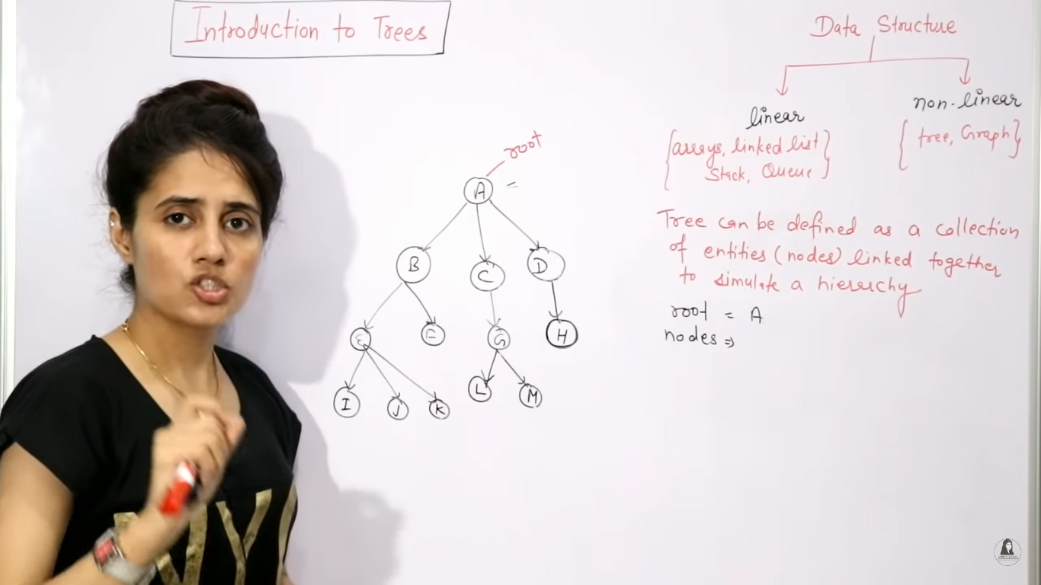

* In the above tree

Root==> A

Nodes ==> A,B,C,D,E,F,G,H,I,J,K,L,M

Parent Node==> G is the parent of L and M

Child Node ==> L&M are children of G

Leaf node ==> leaf Node means which are not having any child Nodes I,J,K,F,L,M,H

Non-leafNodes ==> which is having atleast one child node is called non-leaf nodes,inthis all the other nodes except leaf nodes are non-leaf nodes.also called internal nodes A,B,C,D,E,G

Path ==> Sequence of consecutive edges from source node to destination nodes.

Ancestor ==> any predecessor node on the path from root to that node

L==> A,C,G

Descendent ==> any successor node on the path from that node to leaf node.

C==>G,L,M

Sibling==> all the children of same parent is called sibling E and F are Siblings because they are child of B

Degree==> The number of children of that Node.

Depth of node==> length of path from root to that node.

Height of Node ==> from that node to leaf in the longest path.

Ex :Height of B is 2 because its having maximum two edges till leafs.

Level of Node==> is the distance from root to the given node.

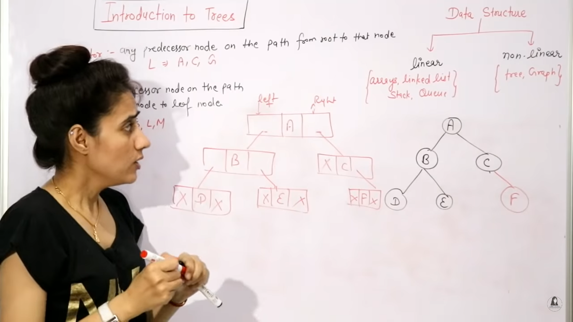

Binary Tree & its Types

Each Node can have atmost 2 Children

Max no of nodes possible at any level i is 2 ^ I (2 sqaure i)

Max no of nodes of height h= 2^h+1 -1(2 power h+1 -1)

Min nof nodes of height h= h+1

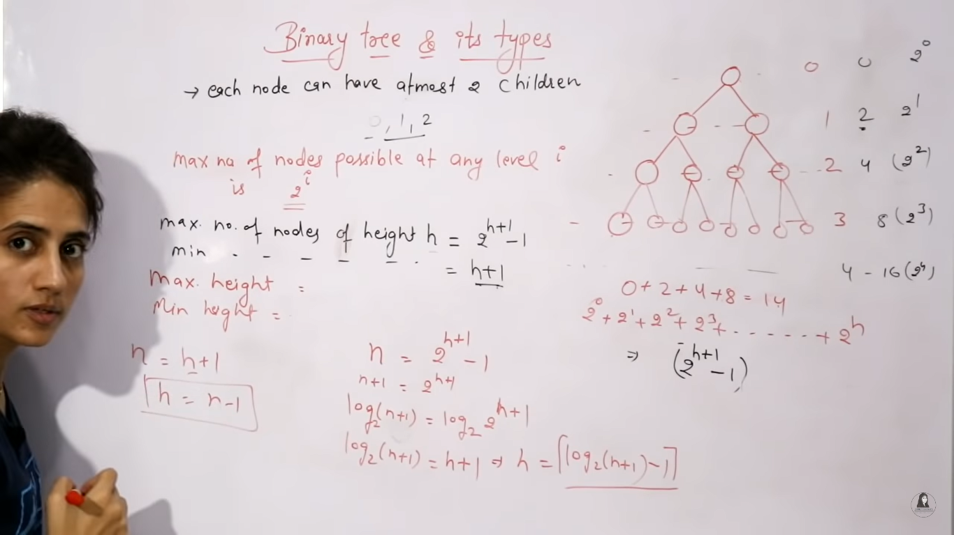

**Full/proper/Strict binary tree:** Each Node have either or 2 Children. Or Each node have exactly two children except leaf Nodes.

No of leaf Nodes=no of internal nodes+1

**Complete Binary Tree:** all levels are completely filled (except possibily the last level) and the last level has nodes as left as possible 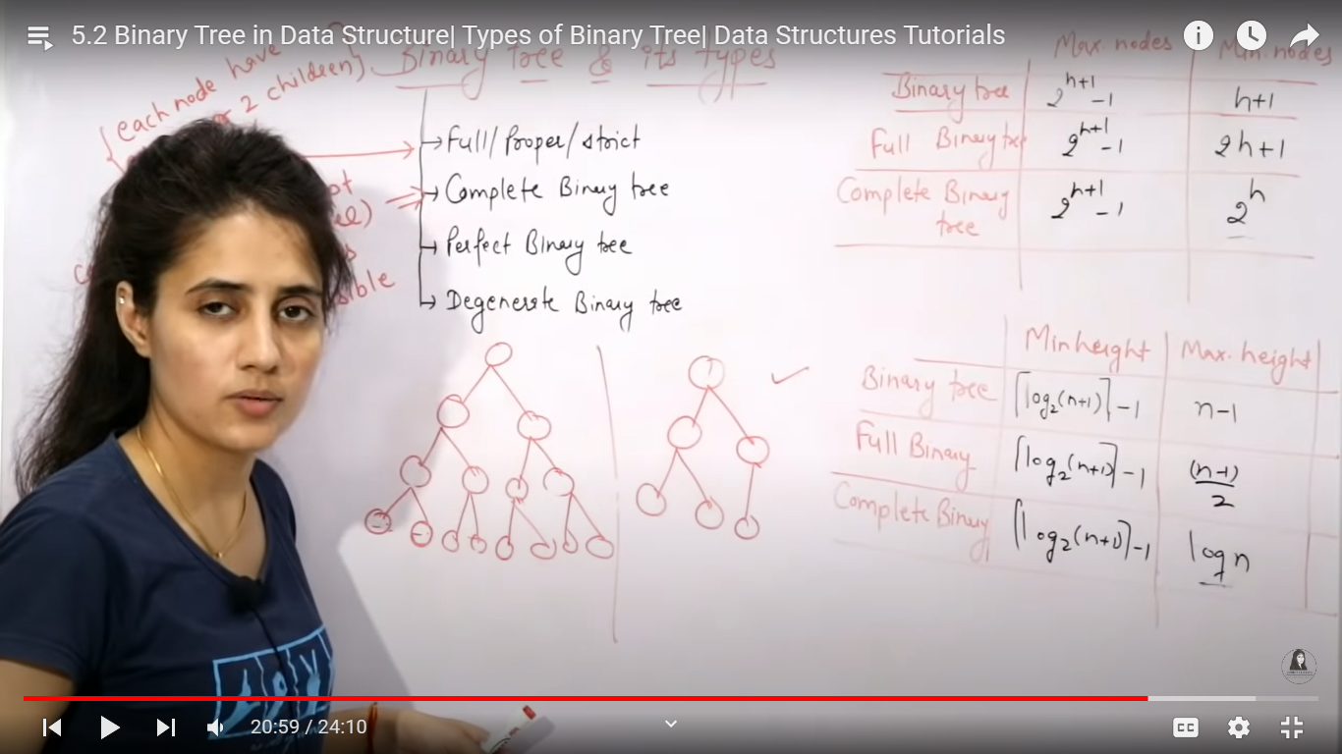

**Perfect Binary Tree:**All internal nodes have 2 Children and all leafs are at same level.

**Degenerative Tree:** Each Internal node Should have only one child called Degenerative Tree.

**Implementation of binary tree:**

import java.util.Scanner;

public class App {

    static Scanner sc = null;

    public static void main(String[] args) throws Exception {

        sc = new Scanner(System.in);

        createNode();

    }

    static Node createNode() {

        Node root = null;

        System.out.println("Enter data :");

        int data = sc.nextInt();

        if (data ==-1)

            return null;

        root = new Node(data);

        System.out.println("Enter left for :" + data);

        root.leftNode = createNode();

        System.out.println("Enter right for :" + data);

        root.rightNode = createNode();

        return root;

    }

}

public class Node {

    private int data;

    Node leftNode;

    Node rightNode;

    Node(int data) {

        data = this.data;

    }

}

Array Representation of Binary Tree

**Note:**The binary tree which is given we have to make that binary tree complete binart tree (left most are filled).

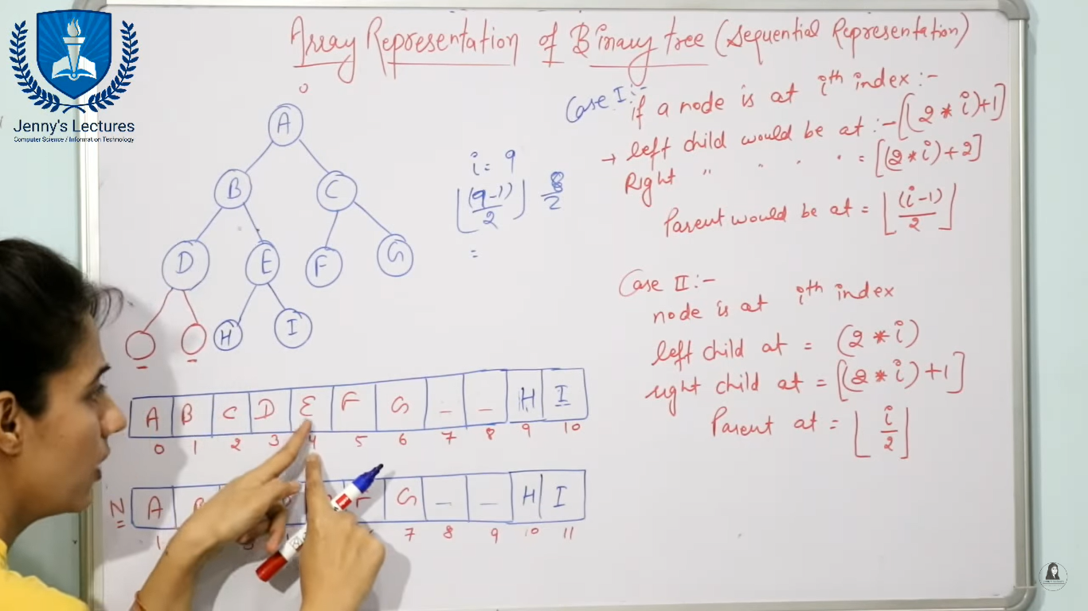

**Traversal of Binary Tree:**

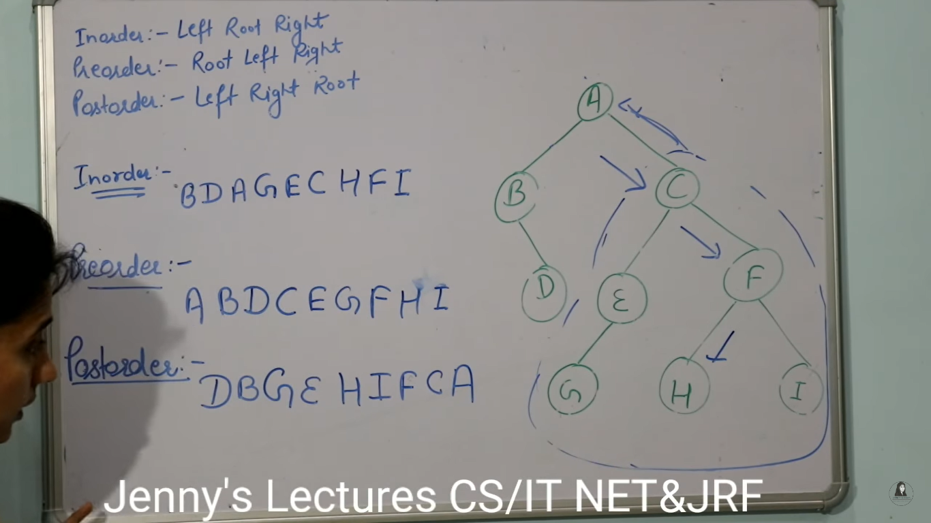

Binary Tree Traversal

import java.util.Scanner;

public class App {

    static Scanner sc = null;

    public static void main(String[] args) throws Exception {

        sc = new Scanner(System.in);

        Node root = createNode();

        inOrder(root);

        System.out.println();

        preOrder(root);

        System.out.println();

        postOrder(root);

        System.out.println();

    }

    static Node createNode() {

        Node root = null;

        System.out.println("Enter data :");

        int data = sc.nextInt();

        if (data == -1)

            return null;

        root = new Node(data);

        System.out.println("Enter left for :" + data);

        root.leftNode = createNode();

        System.out.println("Enter right for :" + data);

        root.rightNode = createNode();

        return root;

    }

    static void inOrder(Node route) {

        if (route == null)

            return;

        inOrder(route.leftNode);

        System.out.println(route.data);

        inOrder(route.rightNode);

    }

    static void postOrder(Node root) {

        if (root == null)

            return;

        postOrder(root.leftNode);

        postOrder(root.rightNode);

        System.out.print(root.data + " ");

    }

    static void preOrder(Node root) {

        if (root == null)

            return;

        System.out.print(root.data + " ");

        preOrder(root.leftNode);

        preOrder(root.rightNode);

    }

}

class Node {

    int data;

    Node leftNode;

    Node rightNode;

    Node(int data) {

        this.data = data;

    }

}

Construct Binary Tree From Postorder & Inorder

PostOrder:9,1,2,12,7,5,3,11,4,8 (Left,Right,Root)

Inorder:9,5,1,7,2,12,8,4,3,11 (Left,Root,Right)

Step1:First we need take the last element in post order it is the our root node

Step2:Then in the inorder what ever the items present left to the 8 is left child and the items right to the 8 is right child .

So our left sub tree is 9,5,1,7,2,12 and right sub tree is 4,3,11

Step3:now we need to construct left part first, so check which element(9,5,1,7,2,12) in post order is comes first(right to left) that is the root node . in our case 5 comes first so 5 is our root node.

Step4: apply same process divide left and right sub trees so 9 is the left part and 1,7,2,12 is the right part.

Step5:we need to find the next root again so check which element is coming first in (1,7,2,12 ) in pre order that 7 is coming first. So 7 is our root node.

Step6: and agin the same process to deivide left and right sub tree 1 is left and 2,12 is right.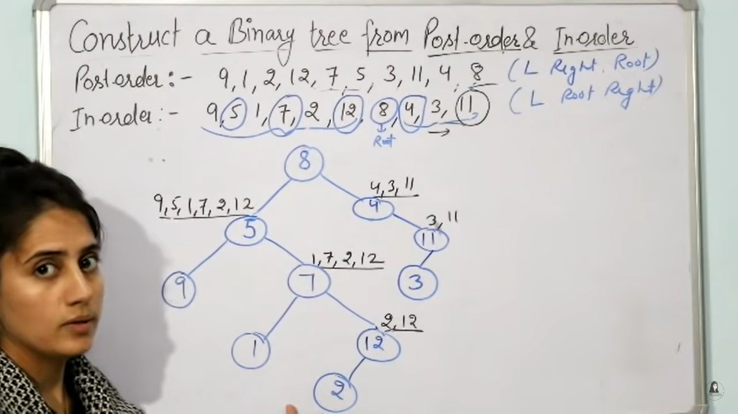

Construct Binary Tree From Postorder & Preorder

Preorder: F B A D C E G I H (Root, Left, Right)

Postorder:A C E D B H I G F (Left,Right,Root)

Step1:find out the Root Element its simple the fisrt element in pre order and last element in post order is our Root.

So our root is **F**

Step2: Our next job is to Find left and right Subtree of F. Find Successor of F in preorder that is B, What ever the elements are there till B from left is left sub tree of F and items right to B is the right sub tree of F

Right ==> A E C D

Left ==>H I G

Binary Search Tree

Condition 1: The left sub tree of any node will have value less than that node and right subtree of that any node will have value greater than that node.

Ex: 11,6,8,19,4,10,5,17,43,49,31

Step1:first we need to add Node 11 it is root node so we can directly assign .

Step2:we need to add 6, so we need to check some conditions

Condition1:check whether 6 is less than or greater than 11, so 6 is less than 11, so we need to assign it as left sub tree of 11. If in case greater than 11 we need to add it in right sub tree.

Step3:next we need to add 8,

Condition 1: check wether 8 is less than or greater than 11 it is less than ,so we need to assign it left side, but 6 is is already there in left.

Condition2:now compare it with 6 so 8 is greater than 6, so we need to assign it right of 6.

Step4:we need to add 19

Condition 1: so compare 19 with 11, so 19 is greater than 11 so assign 19 to the right of 11

We can apply same logic for all if it is less than add it to left if it is greater then add it to right.

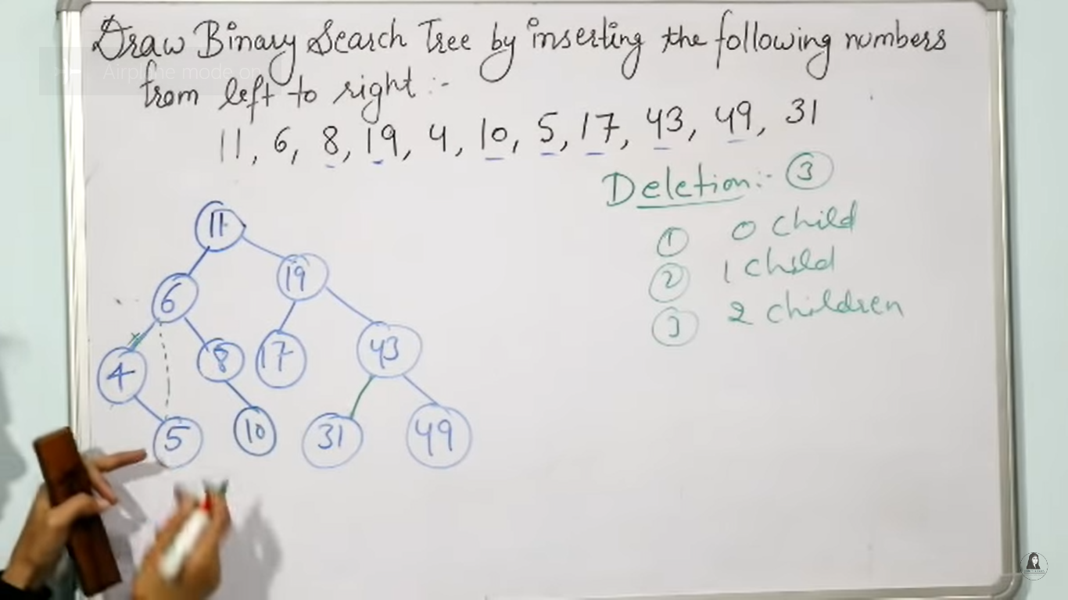

**Deletion in Bst:**

**Case1:**if we want to delete the node which is having 0 childs then simply delete that node and free that node.

**Case2:** if we want to delete the node which is having 1 child ,then delete that node and replace that node with left or right of its child

Ex:if we want to delete 4 then replace 4 with 5 as shown above diagram.

**Case3:** if we want to delete the node which is having two children then we have two options.

**Option1:** inorder predessor

Means the largest element of the left sub tree of that node

Ex: if want to delete 11 then the largest number in left subtree is 10 so we need to replace 11 with 10.

**Option2:**inorder successor

Means the smallest element in the right sub tree of that node.

Ex: if want to delete 11 then the smallest number in right subtree is 17 so we need to replace 11 with 17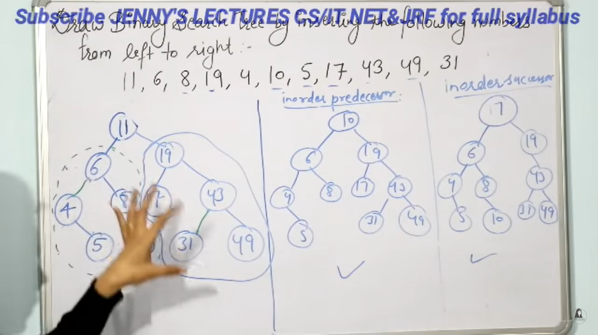.

Construction of Binary Tree From Preorder

Preorder:20,16,5,18,17,19,60,85,70 (Root,Left,Right)

Note: In Order Traversal of Binary Search Tree is always in ascending Order.

Inorder:5,16,17,18,19,20,60,70,85 (Left, Root,Right)

Step1:First we need to Find the Root from Preorder because The first element is Root

In Preorder so 20 is our Preorder.

Step2: Then devide the left and right sub tree with Inorder ,so what ever the items

present left to 20 is left sub tree and what ever items present right to 20 is right sub tree.

Left part ==>5,16,17,18,19

Right Part ==> 60,70,85

Step3:we need to find the Root element the 5,16,17,18,19 to construct left sub tree.

So scan the preorder from left to right which is coming first in these elements will be the root element.

So 16 is coming first ,16 will be the root .

Step4:Now we need to identify left and right subtree for 16, items left to 16 is left sub tree and right to 16 right sub tree.

5 is the left subtree and 17,18,19 are the right sub tree.

Step5:Again we need to find root in 17,18,19 so same proccess which coming first while scaning from left to in preorder wil be the root.

18 will comes first.

Step6:same process deivide the left and right parts of 18 . 17 is left sub tree and 19 will be the right sub tree.

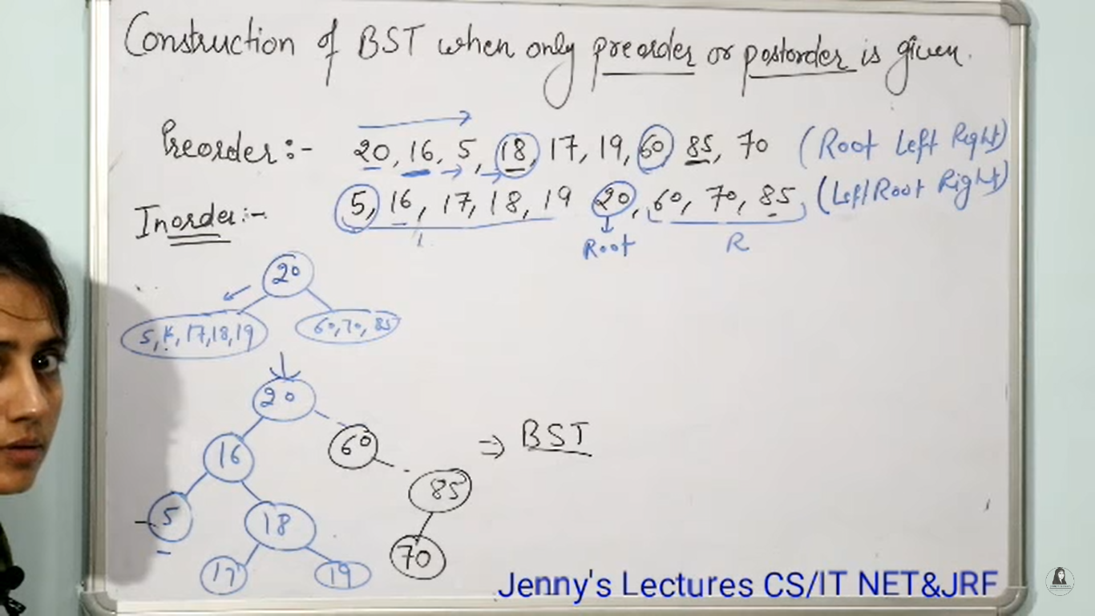

Construct Binary Search Tree from Postorder

PostOrder:5,17,19,18,16,70,85,60,20 (Left,Right,Root)

Step1:we need to find out the Inorder First

Inorder:5,16,17,18,19,20,60,70,85 (Left Root Right)

Note :The main difference bitween previous one and current one is we need scan from right to left

Step1:we need to find root element so we need to scan from right to left first element is 20 ,so 20 is our root.

Step 2:then we need to find and and right from inorder 15,16,17,18,19 is the left sub tree and 60,70,85 is the right sub tree

Step3:Then we need to construct the second root element so again scan from right to left which coming first that is the root.

So 16 is coming first so 16 is our root node. And same for all the nodes.

AVL Tree

1. It should be a BST
2. Height of left subtree -height of right sub tree ={1,0,-1}
3. The above difference is called balance factor, for each Node balance factor should be calculated.
4. In the Avl tree there are 4 types of cases are there

**Case1:** if we want to insert x,y,z in the below format

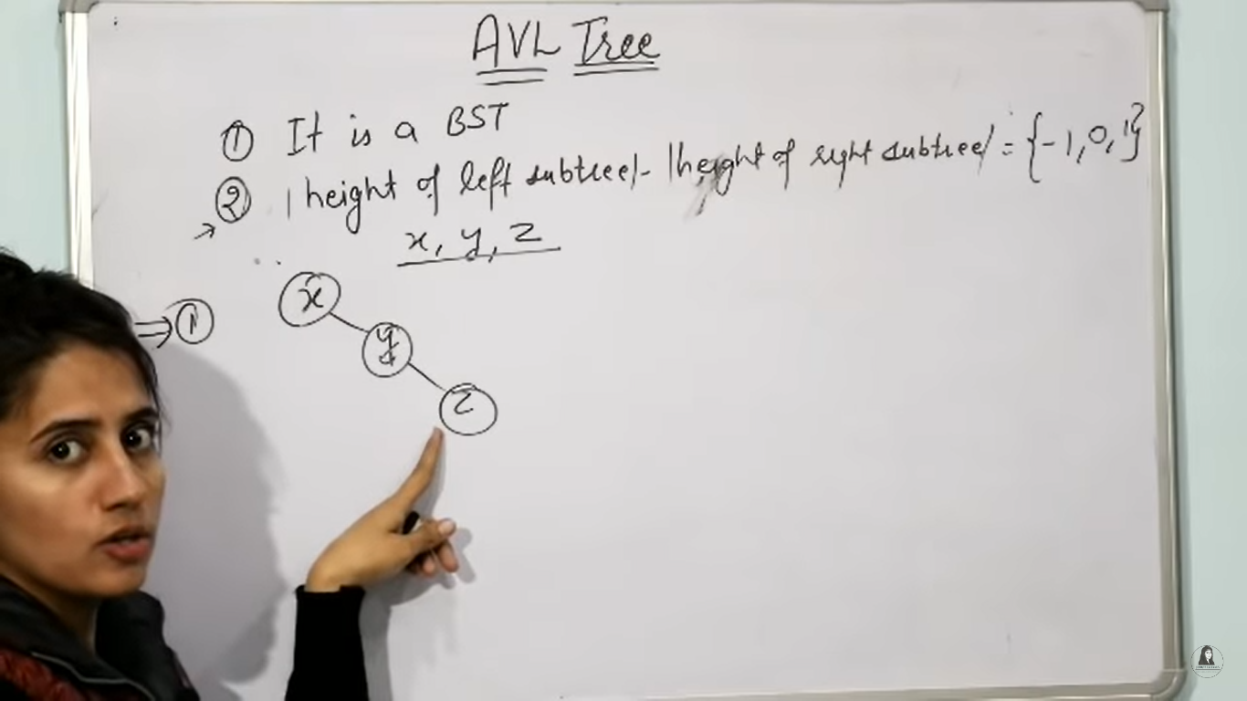

Then we need to calculate the balance factor for each node.

The balance factor for this tree is 2 so tree is unbalenced we need to balance it so we need to do a left rotation because it is having right-right insertion.

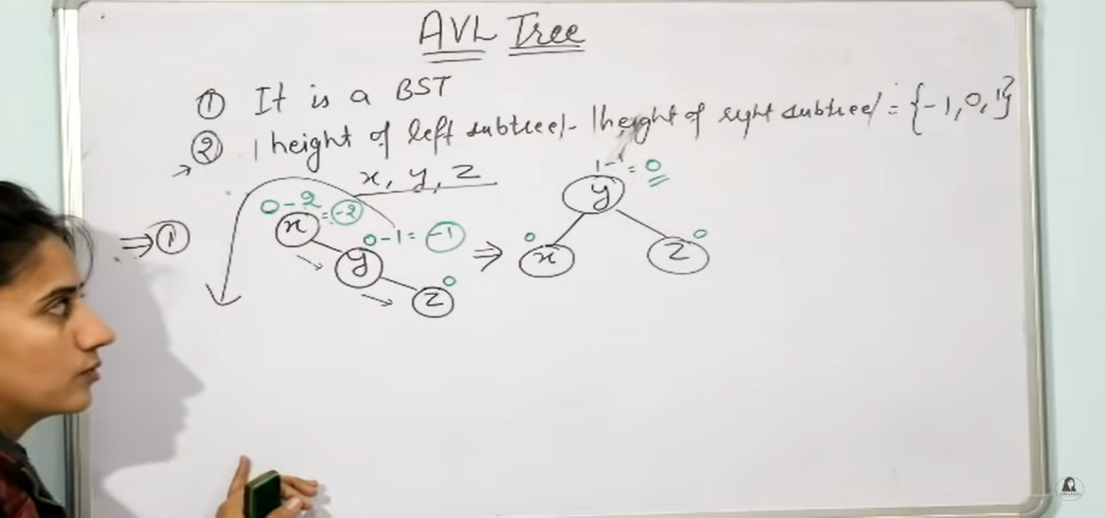

**Case2:**

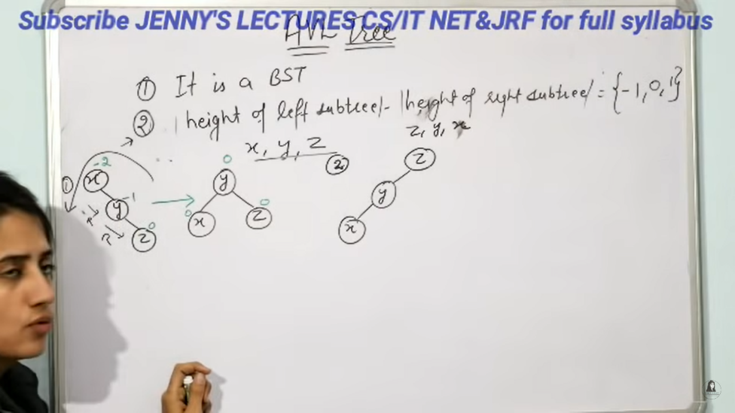

In this case the elements are inserted in left -left structure ,so we need to calculate the balance factor

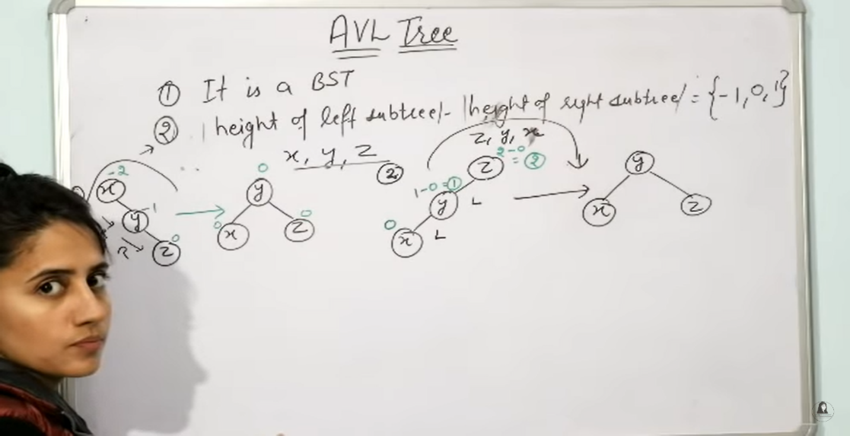

Then we need to a right rotation because its left-left structure now the tree is balenced.

**Case3:**

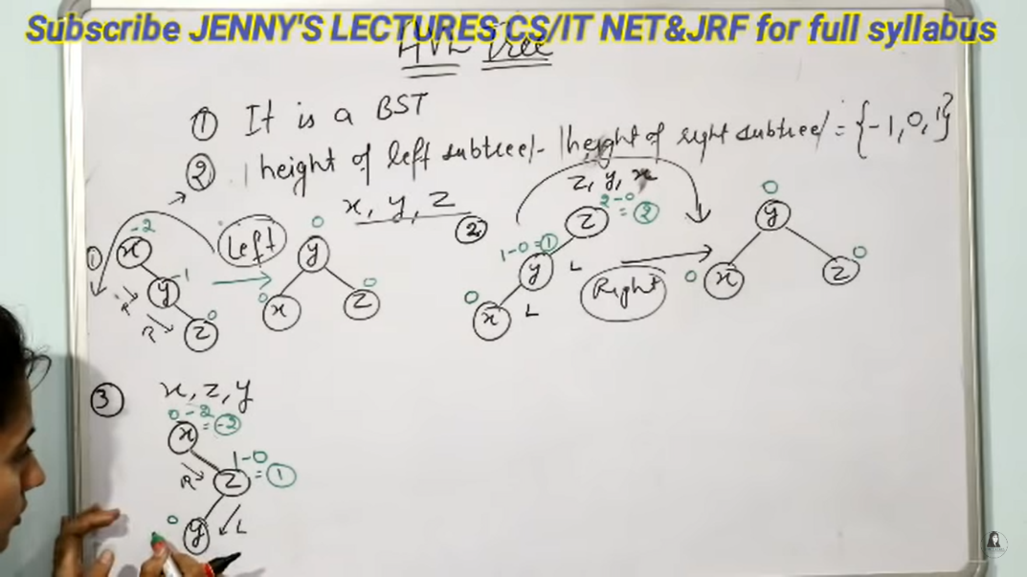

In the case 3 we need to insert x,y,x so first we need to insert in right and then we need to insert into left.

Then we need to check balance factor for this also. The balance factor is -2 for this.

So we need to balance it, so we need to do a right rotation and then left rotation because we have first right insertion.

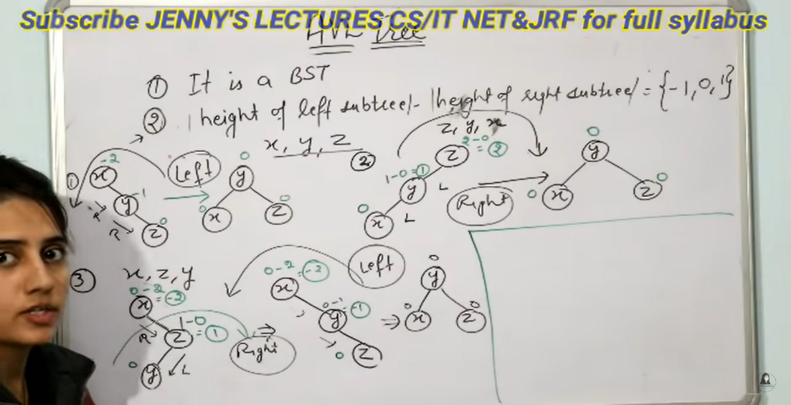

**Case4:**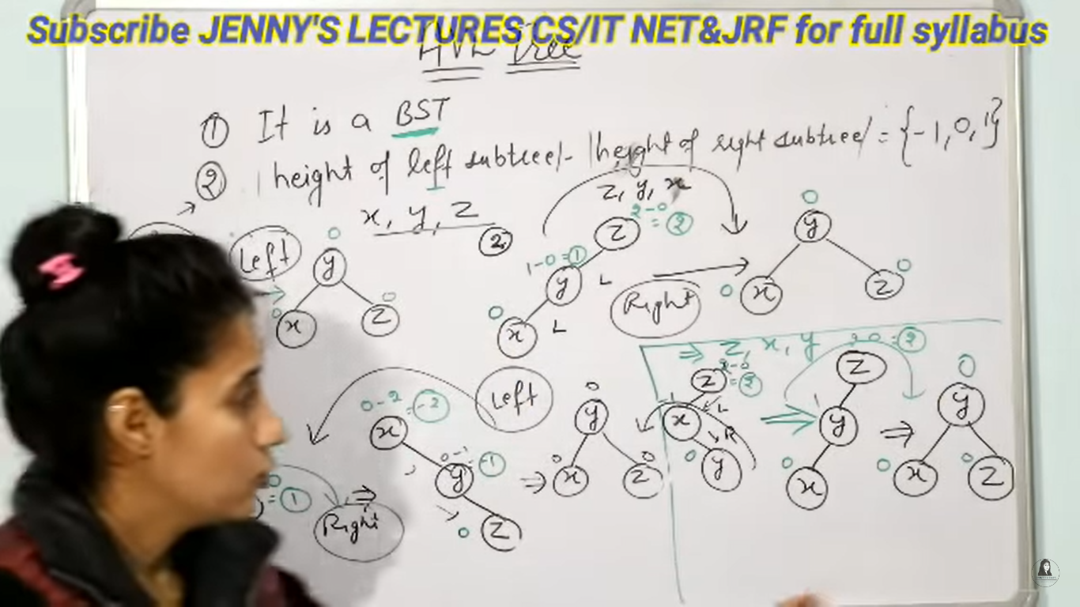

Introduction To Red -Black Trees

* It is a self balencing BST
* Every Node is either Black or Red
* Root is always Black
* Every Leaf which is nil is Black
* If node is Red then its Children are Black
* Every path from a node to any of its descendent Node has same no of Black nodes

Insertion In Red -Black Trees

* If Tree is empty, Create new Node as root node with color black.
* If tree is not empty,create new node as leafnode with color Red.
* If parent of new node is black then exit.
* If parent of new node is Red ,then check the color of parents sibling of new Node.

1. If color of parent sibling is black or null then do suitable rotation and recolor it.
2. If color is Red then recolor and also check if parents parent of newnode is not root node then recolor it & recheck.



Introduction to Splay Tree

1. Self Adjested BST

Operations:Search ,insert,delete same as AVL and Redblck tree.

But this is performed a extra operation of Splay.

**Splay:** if we want to search a element then we need to make that node as root node.

Example:

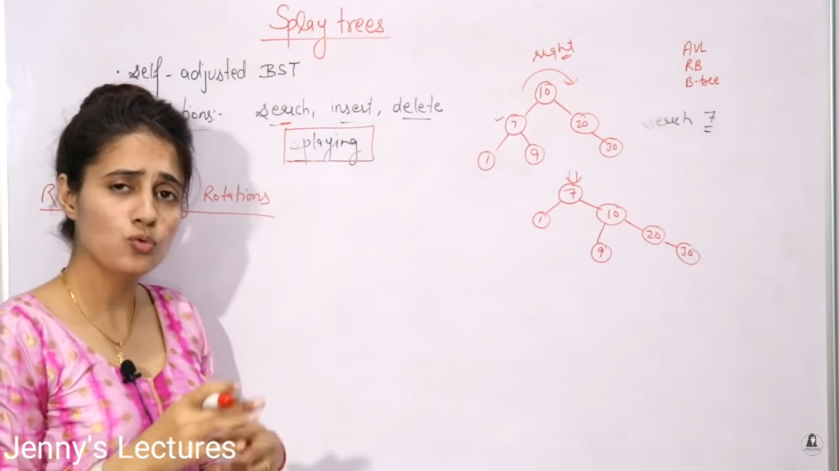

In the above example we want to search 7 , So 7 is left of Node 10, so we need to do right rotation.

For example if want to search 9 , then 9 is right of 7 so first we need to do left rotation and then it its left for 10 so we need to do right rotation .so it becomes root.same apply for all.

Note: we need to splay till grand parent only, if still our node is not root then we need to splay from there onwards.

**Advantages and Applications:**

1. No Extra info stored.
2. Fastest type of BST for many Practical applications.
3. Easy implemntation.
4. Better permance because frequently accessed nodes will move near to root.
5. It is best suited for develop cache based applications.

**Disadvantages:**It is not Strictly Balenced.

Very rarly it will takes time complexity of Teta(n).

Usually it will take log(n) time complexity.

Insertion in Splay Tree

15,10,17,7,13,16

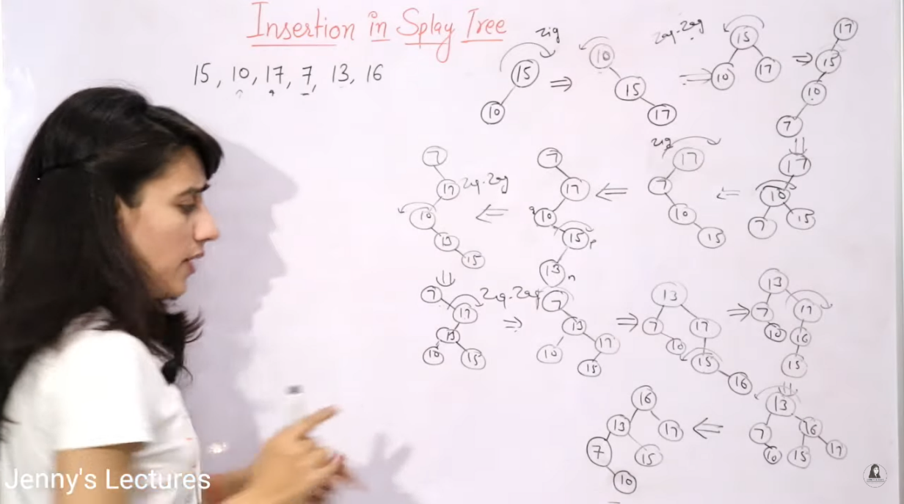

Overview code to insertion of splay tree:

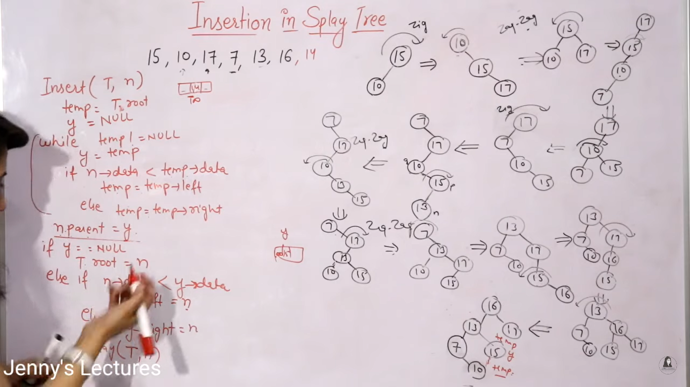

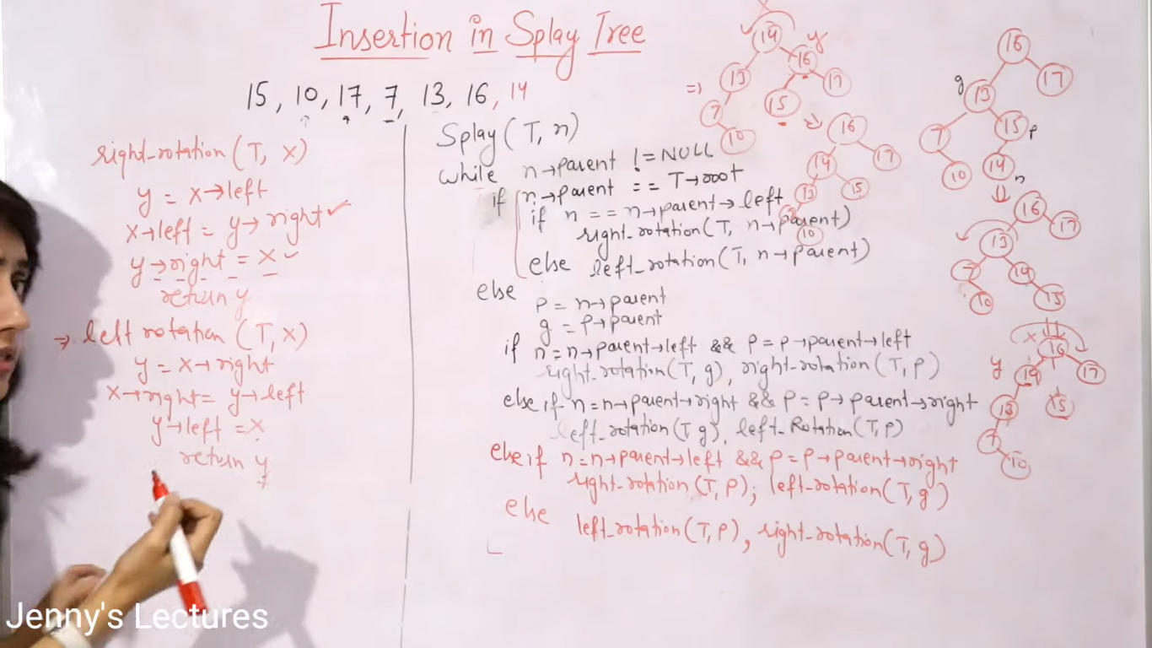

Deletion In Splay Tree

* To Delete a Element in splay Tree We need to follow two steps

1)Perform Standerd BST Deletion.

2) Splay the tree on the element which is parent of node we have deleted.

Ex: 12,14,16

In this Example First we want to delete 12 ,so 12 is leaf node its not having any child so we can simply delete it and start splay from its parent node, so 10 is its parent, so splay 10 untill it becomes Root.

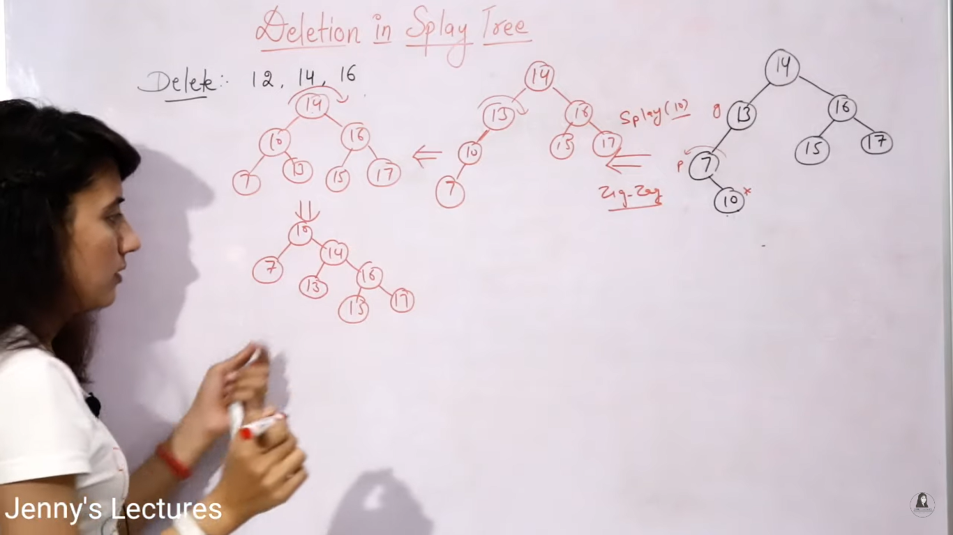

Next we need to delete 14, so 14 is internal node we need to replace it with largets left subtree child or smallest right subtree child here we replace it with 15 .

So we need to start splay from its parent 10 . so 10 is already in root so no need to splay.

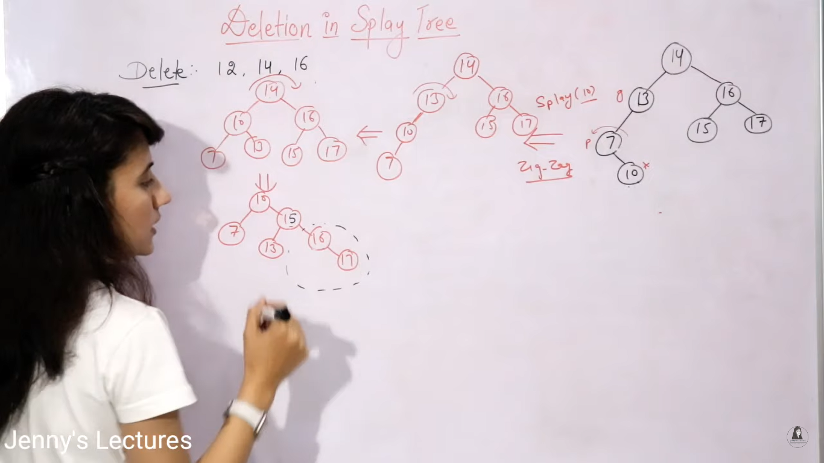

Next step is we need to delete 16. So 16 is internal node so we can replace it with 17.

And start splay from its parent 15 .

So do left rotation and make 15 as root.

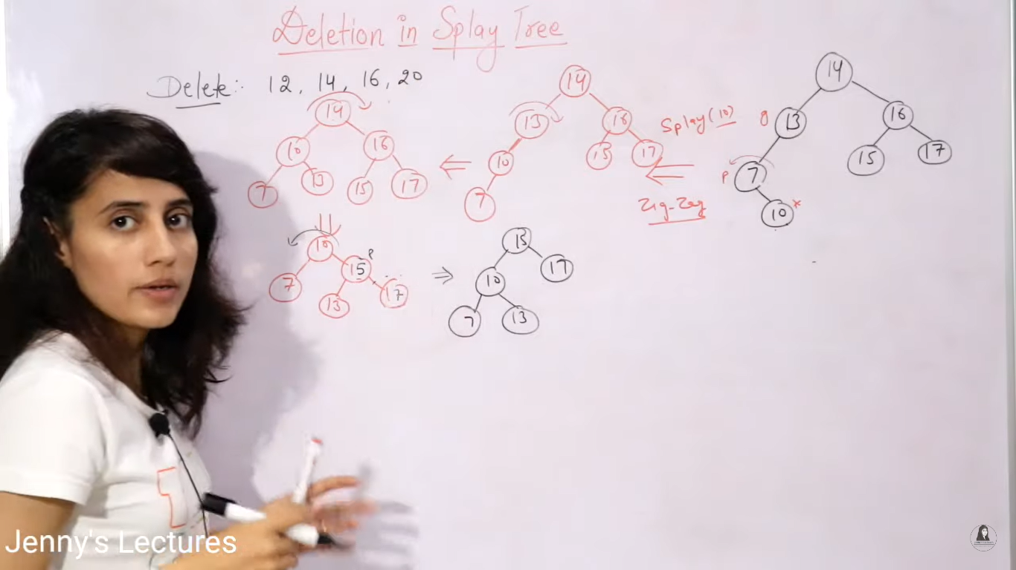

Spray Tree Deletion Top-Down Method

**Step1:**In This approch first we need to splay the item that we wanted to delete and then we can delete that item.

**Step2:** Ofter splaying the item becomes that item becomes the root element. so if we delete the item our tree is split into two parts.

**Step3:**so we need to make our largest element in left subtree as root element and then join right sub tree as right part of new root node.

**Step4:** If incase right subtree is null ofter splitting we don’t need to do nothing.

Ex:16,12,7



First we want to delete 16, so first splat the 16 to Root.

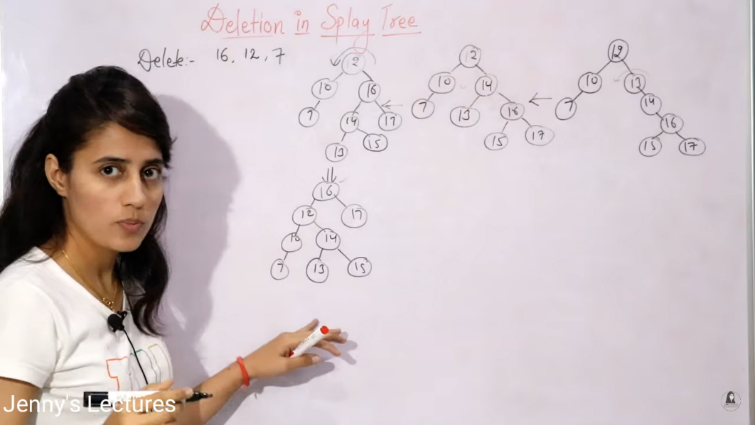

Ofter the splay the tree would look like this.

Then we need to delete 16 Node.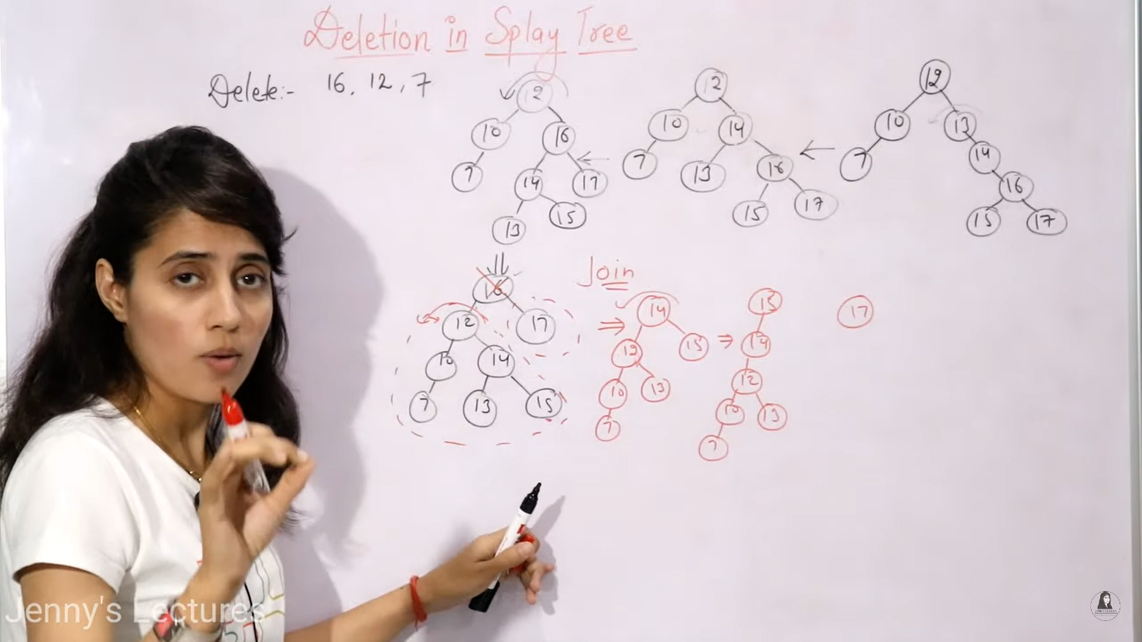

Ofter deleting 16 The tree is now split into two parts so we need to find largest element in the left subtree i.e 15, so we need to perform splay on 15. Like in above diagram.

And the join right sub tree.i.e 17 in right side of 15.

Introduction to B-Trees

* Balenced m-way (order) tree
* Generalisation of BST in which a node can have more than one key & more than 2 children.
* Maintains stored data.
* All leaf node must be at same level.
* B-tree order **m** has following properties.
* Every node has max m children.
* Min children: leaf -->0 root --> 2 internal nodes -->[m/2]
* Every node has max.(m-1) keys
* Min keys: root node --> 1, all other nodes --> [m/2]-1

Insertion of B-Tree Order Three

Creating a B-tree of order 3 by inserting values from 1 to 10

* Here maximum keys would be (m-1) so (3-1)=2
* Values are always inserted in sorted order.

Step1: in step one we need to insert one and then two.so if we want to insert 3 the tree would be overflowed.

Step2: so we need to push the middle element to one level up. So 2 is the middle and pushed to one level up and so remaining 1 is left of two and three is right of 3.

Step3:Next we wanted to insert 4 so first we need to check from the root node so 2 is root now so 4 is greater than 2 ,so 4 is shifted to right of 2 but we need to insert only at leaf node.

Step3: So we need to insert the 4 Right side of 3 .

Step4:then we need to insert 5 so 3&5 are already there inthat node so it is overflowed.so we need to move middle element to one leveup i.e right of 2.

So 4 is the middle element for 3&5 so we need shift to onelevel up to right of 2.

Insertion in B+ Tree

**Diff b/w Btree and B+tree:** The main difference bitween these two trees is in b+ tree we can the store the splitted element in the leaf node as well along with actual data.

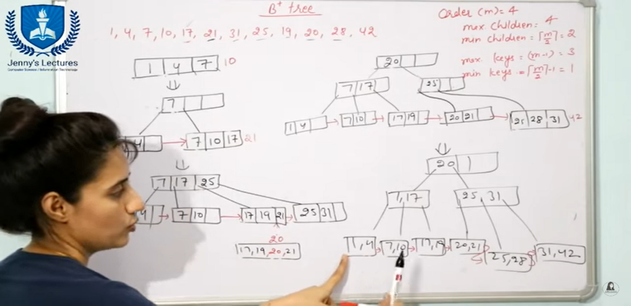

Representation of Graph in Computer

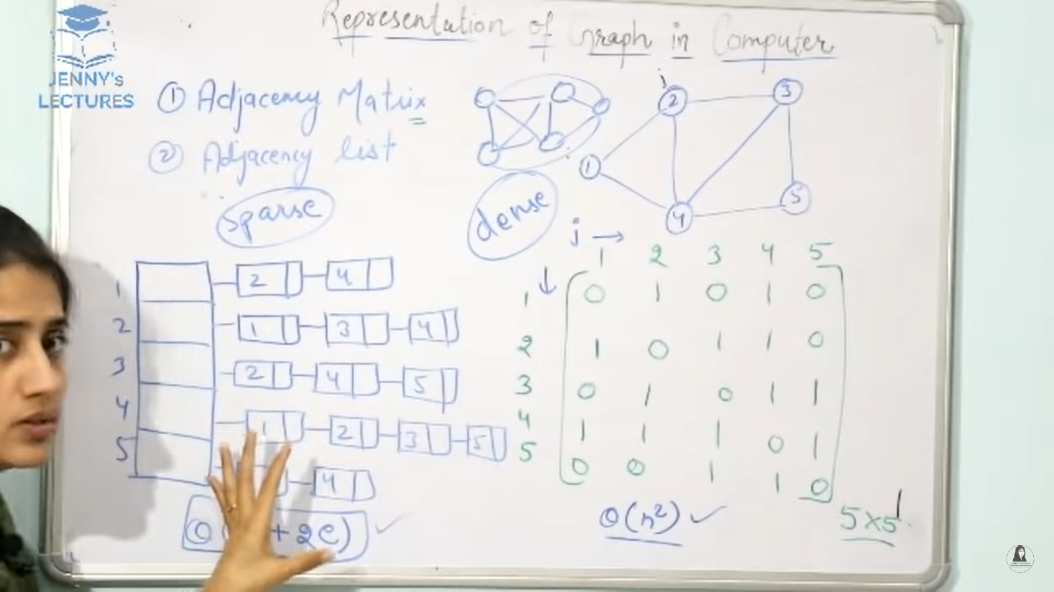

Types of Edges in DFS Traversal

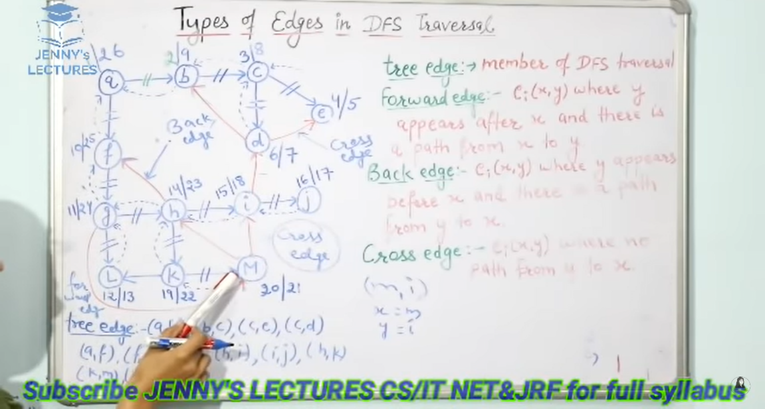

Prims Algorithem

Step1:First remove all the loops and Parallal edges. Loop means incase one edge starts from same node and at same node.

Step2:in two parallal edges we need to keep which edge is having minimum weight. And remove the edge which is having maximum weight.

Step3:In prims algorithem we can choose any node as root Node.

Step4:Checkout all the out going edges from our Root Node. But here we don’t have any outgoing edges we are having only directed edges. So we need to check the incident edges from the Root node.

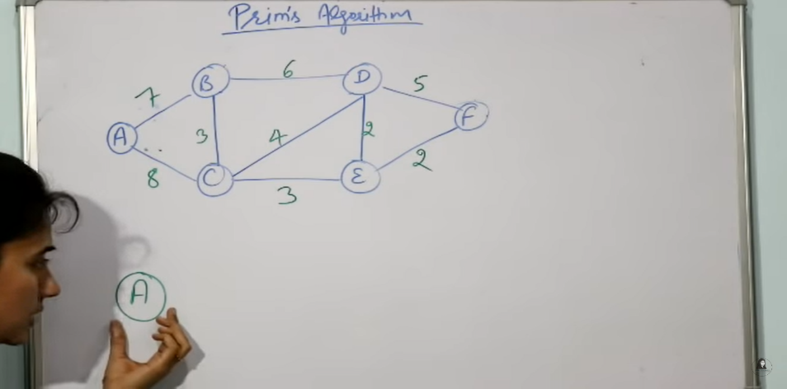

Step5:We need to choose one edge from A which is having minimum weight.

So 7 is having minimum weight.

Step6:Now we are at Node B, So we need to check all incident nodes from B which is having minimum weight and the remaining Nodes from A as well that is 8 . So in in 6,3,8 the node 3 is having minimum weight so we need to move to Node C.

Step7:Now we are at Node C , Now we need to check the edges which is having minimum weight so 3, 4 from C , 8 From A and 6 From B so all of them 3 is having Minimum Weight So we need to move to Node E.

Step8:Now we are at Node E , We need to check all the Edges Which is having minimum Weight So 2,2 From E , 4 From C , 6 From B and 8 From A. So all of the Both 2,2 is having minimum weght so we can Choose either from D and F . Here we Choose F.

Step8:Now we are at F,So chech all the Edges which is having minimum weight so 2 From E, 5 From F, 6 From B ,4 From C, 8 From A, So 2 is having minimum Weight bitween D and E.

So we move to D from E.

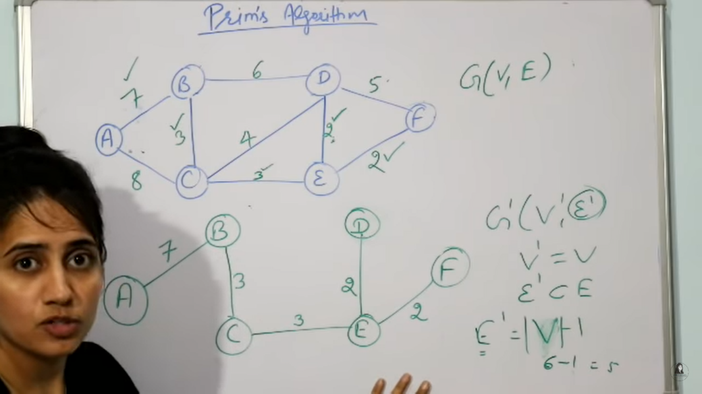

Kruskals Algoritham

Step1:Remove all the Loops and Parallal Edges.in parallel edges keep only which is having minimum weight.

Step2:In Kruskals algo we need to arrange all the edges according to their weight in increasing order of edge weight.

The order is Like

BD=2

DE=2

AC=3

CD=3

BE=4

AB=5

BC=6

AF=7

FC=8

Step3:We need to choose the edge which is having minimum weight from the obove set.

Note:while connecting all Nodes make sure that we are not forming a cycle.(means a loop)

Step4:First we need to join BD ,then DE ,then AC ,then CD

Step5:Then we need to connect BE but if we connect this it will form a cycle, so we cannot connect this edge.

Next one is AB we cannot be able to Connect this as well it is also forms a cycle.

Next one is BC it is also forms cycle so we need to skip that one also.

Next is AF we can connect AF

Next is FC it is also Forms Cycle so we need to skip it.

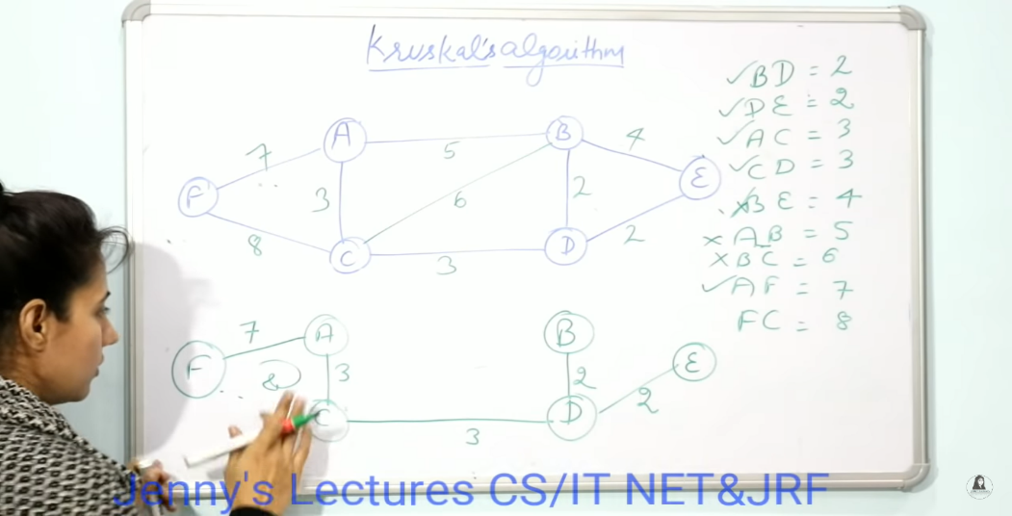

Detect Cycle in Directed Graph Using DFS

* For DFS graph we need to use stack data structure.
* In this we are using a visible set variable to store which nodes are visited and which are unvisited.
* In this we are maintain a vertex and parent map. To store for which node which one is parent.
* In this we are going to use Flag variable

**Flag:**

-1 ==> unvisited

0 ==> visited and in stack

1 ==> visited and poped out from stack

* In Statrting Every vertex is having -1 because no vertex is visited.
* In This we are start traversing From Vertex **A** So Insert The A into Stack and make the vertext of A to 0 . and we will also write Vertex as A and parent is Nothing.
* Next we need to find Adjecent Vertex of A that is B and C we can choose either.Here we are Choosing B.
* So Push the B in the stack and the flag value is 0 and add B in Visited Set.and write Vertex as B and Parent as A.
* From B Find the adjecent Nodes C and D are adejecent Nodes . Here we are Traverse to C, So Now Push the C to the Stack. And add the C to the Visited Set. And Write C as Vertex and B as Parent.and Flag of C is 0.
* From C we are Not able to Move any where So we need to back track,So we need to popout C from the stack.Then Flag of C Becomes 1 .Now we are at B Node.
* Now we are Moved to D Node so Push the D into the stack, and make the flag 0.and vertex as D and Parent as B.and add D to Visited Set.
* Now find out the adjecent of D i.e E only so Moved to E add the E to the Stack and add E to Visited set and make the Flag of to 0.and write E as vertex and D as Parent.
* Now we need to find Adjecent Vertex to E i.e B only But we cannot push B to the stack because the flag of B is 0.

Note:When you write the programm in DFS Traversal you have to notify one thing . If Any vertex is find its adjecent vertex with flag 0, it means that graph contains a cycle.

To Find Out Which nodes involved in cycle

First we need to Take B Node because at B only we are getting Flag as 0. And E Node also .

Now Find out Parent of E i.e D so Finally

B-->D-->E-->B

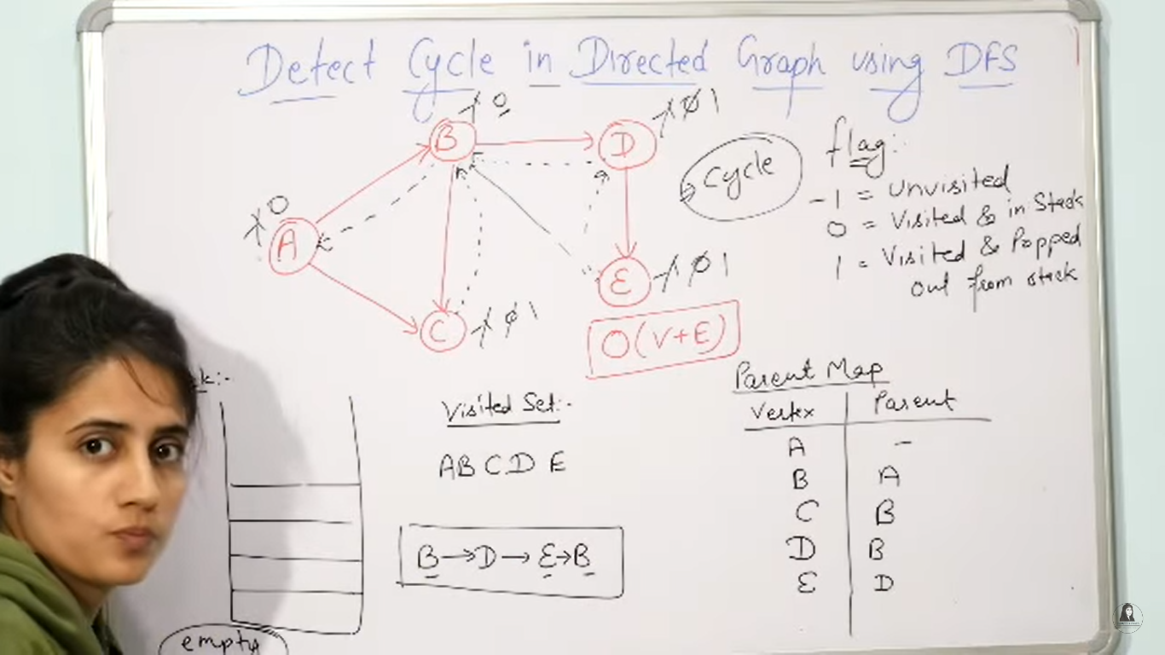

Detect The Cycle in Undirected Graph(BFS)

* In BFS data structure we are using Queue data structure.
* In BFS we will explore One Node and Moves Further.
* Here also we are using Flag

Flag:

-1 --> Unvisited

0 --> Node is in Queue but not visited

1 --> Node is Visited

* Initially Flag of Every Node is -1 because no node inserted or visited initially.
* We can start BFS traversal from any Node Here we are start from A Node.
* So Now we are inserted A into Queue ,so we need to mark the Flag of A is 0 and A is deleted and Printed.
* So now add all the adjecent vertxes of A to the Queue i.e B and C are adjecent to A so we will add them to Queue .
* So Now The Flags of B and C becomes zero.And A is visited so Flag of A becomes 1.
* Now B would be deleted and printed, then the flag becomes 1.So Now check the adjecent Vertexes of B.i.e A,D,E we will not put A into queue because A is already Visited.
* So we are Put Remaining E and D into Queue and make the flags of E and D to 0.
* Then we delete C from Queue and print the C, So the Flag of C become 1.
* Now Checkout the Adjecent Nodes of C i.e Only A but its already visited.
* So Next is Delete D from Queue and Flag of D becomes 1. And Find the adjecent Vertices of D i.e E and B. So B is visited but Flag of E is 0.

Note: If any Vertex finds its adjecent vertex with Flag 0, then it Contains Cycle.

Topological Sort

* It is a linear ordering of its vertices, such that for every directed edge uv for vertex u to v, u comes before vertex v in the ordering.
* Graph should be Directed Acyclic Graph (DAG).
* Every DAG have atleast one tropological order.

Step1:First we need to find out the In Degree of Each vertices. In the directed graph we have the concept of in degree and out digree. Indegree means the number of edges coming towards that Node. Outdegree means the number of edges outgoing from that Node.

Step2: we need to start writing topological order from the vertex having Indegree 0.

In our example 1 is having 0 indegree so we are selected one.

Step3:From Our Graph we need to delete Node 1 and all the edges which are outgoing from that Node.

Step4: because of that deletion Indegree of all the Nodes changed so we need to calculate Indegree of all Nodes again.

Step5: Now the Node 2 is having indegree of zero.so we will delete Node 2 and all the out going Nodes From Node 2. And calculate the indegree again.

Step6:Now 4 will be deleted and all the outgoing Nodes From 4 Will be deleted.

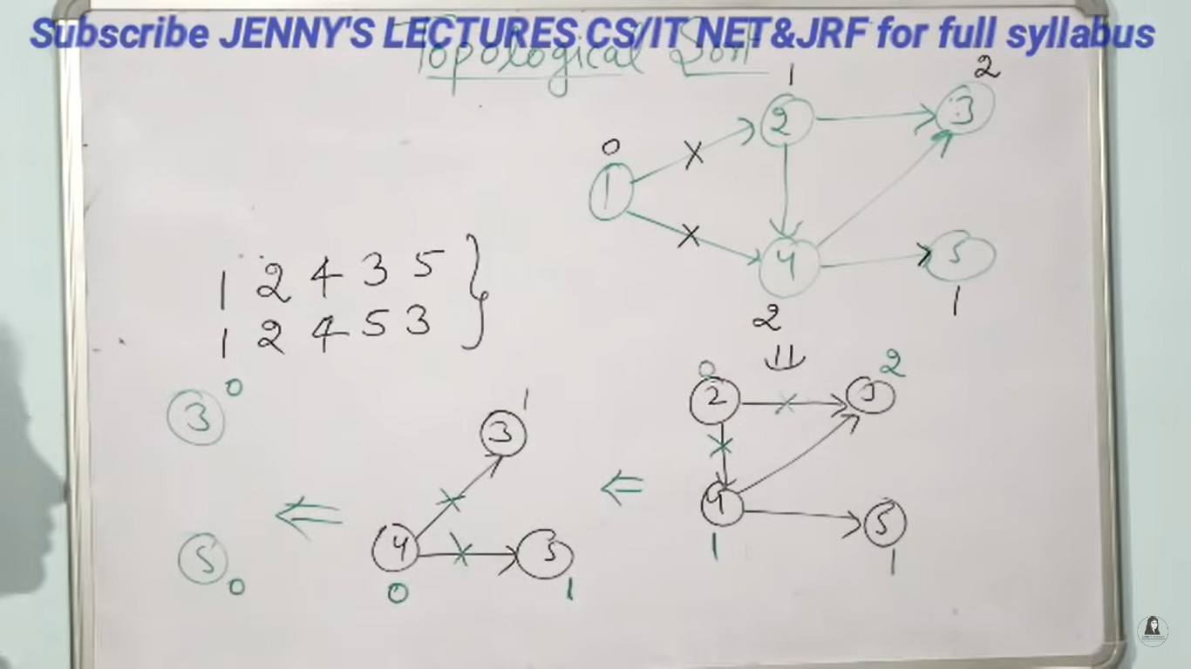

Connected Components



Find All Bridges of Graph

Bridge:Its an edge who’s removal will increase the number of connected components in a graph.

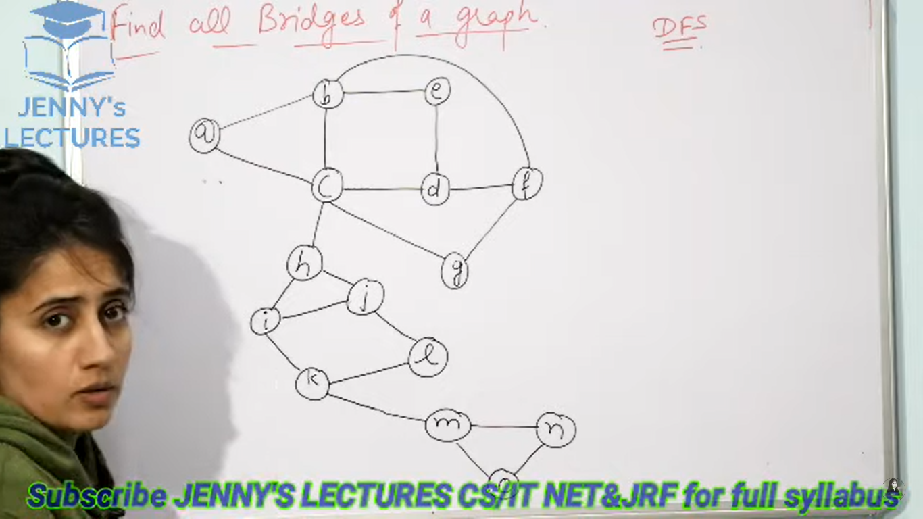

Step1: In this graph we are using DFS Travel, to find out the bridges.So we are starting our traversal From Node D.

Step2:The starting time at D node is 1, From Node D we are moving to F Node.starting Time of F is 2.

Step3: From F we are moved to G,the starting time of G is 3.Now we are moved to C the starting time of C is 4.

Step4:From C we are moving to B Node the starting time of B is 5.From B we are moving to A Node the starting time of A is 6.

Step5: From A we are not able to move any to any where so we need to backtrack to B. So B can say I know you I can remove you and you will be disconnected.

Step6:Now A will check all adjecent vertices except its parent. So A will check minimum starting time of all its adjecent Nodes, in our case C is the only adjecent having mimumum starting time. So A will take the minimum starting time From C and maitain it in array.

Step7: Now A can tell to B I know some who’s minimum starting time is better than you.

If you remove this edge I still connected to the graph.

Step8:Now we are at B From B we are moved to Node E. The starting time of E is 7. We cannot goto any where we From E, we need to backtrack.

Step9:So now B will say I know you if I remove this edge you will be disconnected.

So E is check all its adjecent Nodes for who is having minimum starting time which is less than its parent B.

So E is having only D as its adjecent the minimum starting time is 1 For the Node B.

So E can I still connect with graph event you remove this edge.

Step10: Now From B we need to backtrack to its parent C. so same proccess So B Node check all its adcent Nodes So E is Now having 1 as minimum so it will barrow from it.

Step11: Now From C we can go to H starting time of H is 8 and From H we can go I the starting time of I is 9. And From I we can go to K the starting time of K is 10 ,

From K we can go to L the starting time of L is 11 , From L we can go to J starting time of J is 12.

Step12:From J we need to back track to L Node ,So L say I know you if I remove this edge you will disconnected. So Now J is checking its Adcent Nodes H is having starting time of 8 which is less than L(11) so it will barrow 8.

Now we are Node L. From L we need to backtrack to K . so same L will check for adjecents Now J is having 8 as starting Time so it will barrow 8 From J.

From K we can go to M starting time of M is 13, From M we can go to N starting time of N is 14.

From N to we can go for O node, the starting time of O is 15.

Step 13:From Node O we need to backtrack to it parent N, So now O is check its adjecent nodes. So M is having 13 which is less than 14. So it will barrow 13.

Now we are at N node,we need to backtrack to M so now M will check its adjecent Nodes so Now O is having 13 it will barrow 13.which is equel to its parent M.

Now we are at Node M, now we need to backtrack to its parent K, now M needs to check its adjecents who’s having minimum starting time less than its parent K. So n is having 13 and O is having 13 but which is not lessthan K.

Step14: Now K is say that If I remove this edge you will be disconnected. So M cannot be able to say something becuase it does not know any node which is having starting time less than K.

So this Edge is acts like a bridge bitween M and K.

Now from K we need to backtrack to I node .before backtracking K will check the minimum starting time from its adjecent Nodes, so from l and M, l is having minimum starting time of 8 so it will take 8.

Now we are at Node I we need to backtrack to Node H, so before backtracking I need to check its adjecent for minimum starting time, so both J and K are having starting time of 8 , so it will use 8.

Step 15:Now we are at H we need to backtrack to Node C. So before backtrack H will check all of its adjecents I& J are the adjecents of H but both are having start time greater the C Node, So H cannot be able to say any thing.

So The Edge bitween H and C acts like a bridge.

From C we need to backtrack to Node G, before this C will check its adjecent Nodes for minimum starting time D is having minimum starting time so it will take 1 From D.

From G we need to goto F before backtrack G will check its adjecents C is having 1 so it will take From C.

From F we need to backtrack to D node before backtracking F will check its adjecent Nodes so G is having 1 .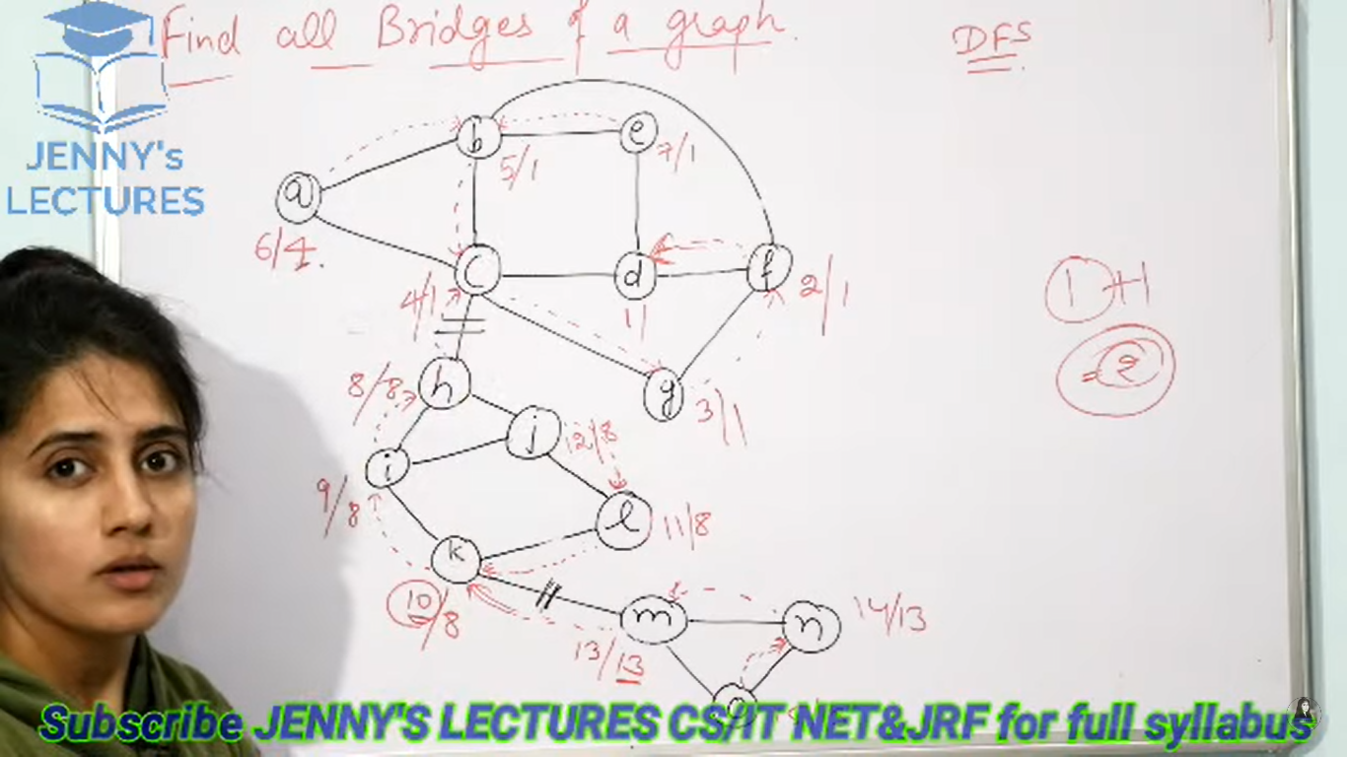

Dijkstra Algorithem

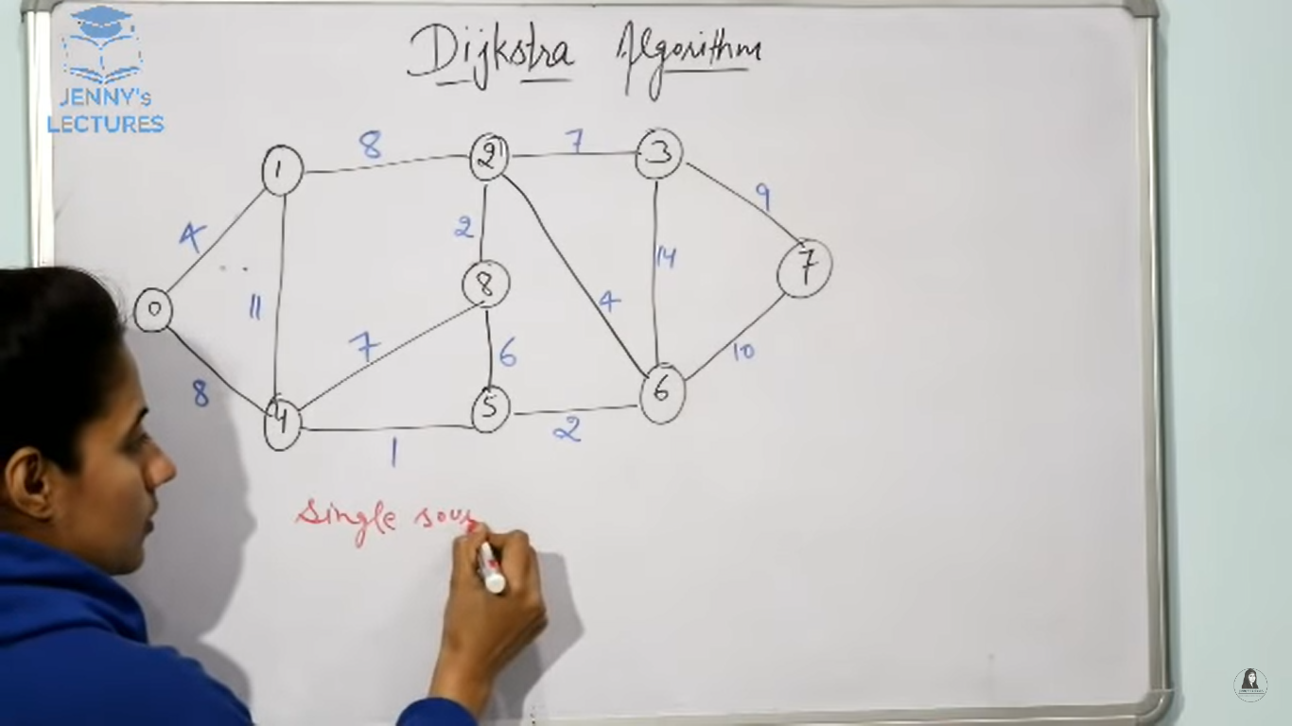

Step1:First select the source vertex which you want to start make the distance of that source vertex 0. And then make all other vertex as infinity

Step2:Here we are considered 0 as source vertex, From 0 only Vertex 1 and 4 are connected,

Step3:For example if we want to calculate distance from 0 to 1,so assume 0 as u and 1 as v.

Our formula is

If(d(u)+c(u,v) <d(v))

So initially d(u) is 0 and c(u,v) is 4 and d(v) is infinity.

So 0+4 <infinity

If this is true we need to update the distance of v i.e d[v]

d[v]=d[u] +c[u+v]

step4:The next adcent of 0 is 4 ,so caluculate shortest path to 4.

If(d(u)+c(u,v) <d(v))

0+8 <infinity

It is true

So d[v]=d[u] +c[u+v]

Step 5: all the adcent nodes of 0 is calculated so mark 0 as visited.

Step6:Now check all the distance of others nodes except 0, select the shortest one among all of them. For Node 4 distance is 8 and Node1 distance is 4, so Node 1 is having small distance so select Node1. (the all remaining nodes are infinity)

Step6:From Node 1 we can calculate the distance Node 4 and 2.

If(d(u)+c(u,v) <d(v)) this condition satisfy then only we will update the distance.

So first we calculate bitween 1 to 2

If(d(u)+c(u,v) <d(v))

4+8 <infinity

It is true

So d[v]=d[4] +c[8]

So the updated distance of Node 2 is 12.

Now we need to calculate distance bitween Node 1 to Node 4.

If(d(u)+c(u,v) <d(v))

4+11 <8

It is false so we are not updating it.

Step7: Now Mark Node 1 as selected. And check all other node who is having lowest distance . Node 4 is having the distance of 8 and Node 2 is having 12.

So 8 is the shortest distance so selcect Node 4.

Now First find the distance from Node 4 and Node 5.

If(d(u)+c(u,v) <d(v))

8+1 <infinity

It is true

So d[v]=d[8] +c[1]

So the updated distance of Node 5 is 9.

Find the distance bitween Node 4 and Node 8.

If(d(u)+c(u,v) <d(v))

8+7 <infinity

It is true

So d[v]=d[8] +c[7]

So the updated distance of Node 8 is 15.

Step8: Now we need to mark Node 4 as visited and select the shortest distance node from all other nodes. For Node 5 distance is 9 ,For Node 8 distance is 15 and Node 2 distance is 12 and remaining are infinity. So Node 5 is having shortest distance.

Find the distance bitween Node 5 and 6

If(d(u)+c(u,v) <d(v))

9+2 <infinity

It is true

So d[v]=d[9] +c[2]

So the updated distance of Node 6 is 11.

Now find the distance bitween Node 5 and Node 8.

If(d(u)+c(u,v) <d(v))

9+6 <15

It is false

So no need to update.

Step9: now mark the Node 5 as visited and go for Next node. So calculate the shortest distance from all other nodes. For Node 8 distance 15, For Node 2 distance is 12 ,for Node 6 distance is 11 ,So Node 6 is the shortest distance .Select 6.

Find the distance bitween Node 6 and Node 7.

If(d(u)+c(u,v) <d(v))

11+10 <infinity

It is true

So d[v]=d[11] +c[10]

So the updated distance of Node 7 is 21.

Find the distance bitween Node 6 and Node 3.

If(d(u)+c(u,v) <d(v))

11+14 <infinity

It is true

So d[v]=d[11] +c[14]

So the updated distance of Node 3 is 25.

Find the distance bitween the Node 6 and Node 2

If(d(u)+c(u,v) <d(v))

11+4 <12

It is false

We are not update the distance.

Step10:Mark the Node 6 as visited and Find the Next Node which is having shortest distance i.e Node 2 with distance 12.

Find the distance bitween Node 2 and Node 8

If(d(u)+c(u,v) <d(v))

12+2 <15

It is true

So d[v]=d[12] +c[2]

So the updated distance of Node 8 is 14.

Find the distance bitween Node 2 and 3.

If(d(u)+c(u,v) <d(v))

12+7 <25

It is true

So d[v]=d[12] +c[7]

So the updated distance of Node 3 is 19.

Step11:Mark Node 3 as visited and select Next node having short distance i.e Node 8.

The all adjecent Nodes of 8 are already visited so leave it as it is. Select Next Node i.e Node 3 is having shortest distance.

So find the distance bitween Node 3 and 7

If(d(u)+c(u,v) <d(v))

19+9 <21

It is false

So we are not going to update it.

Step12: only Node 7 is is left mark this also visited.

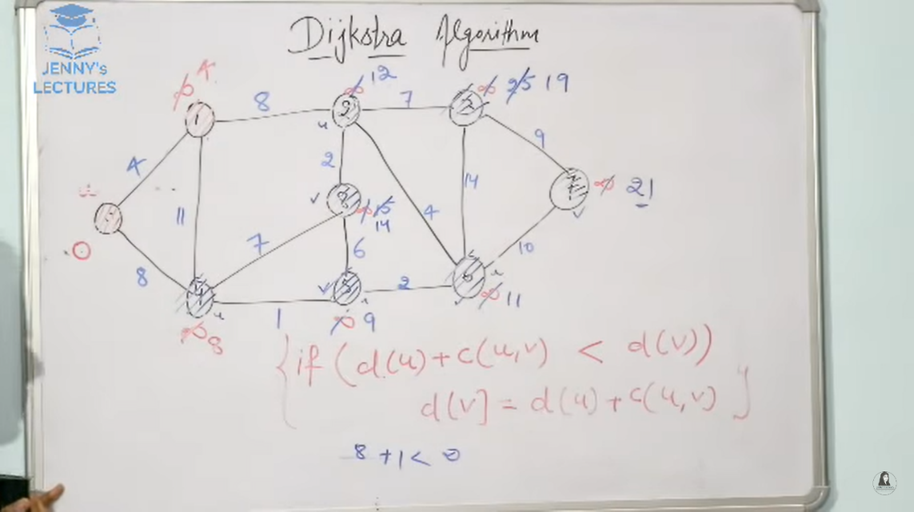

Ex2:

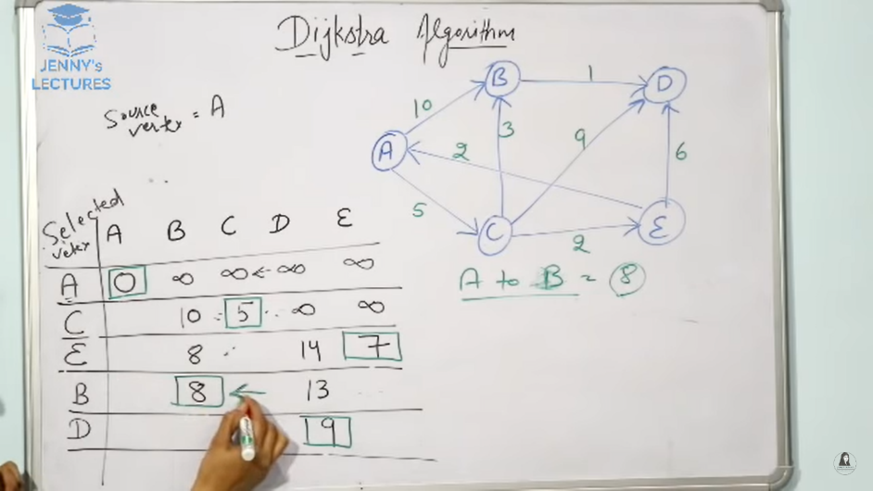

Bellman Ford Algorithem

* It is a single source shortest path Alogorithem
* It helps us to find the shortest distance from one Node to all other Nodes of a weighted graph.
* We have dijkstra algaritham for this but how this bellmanford algarithem is different from dijkistra algarithem, dijkistra is not works for on a graph having negitive weight.
* Dijkistra may give or may not give correct result in the case weighted graph is having negitive wieght.

**Go on relaxing all the edges (n-1) times , n= no of vertices**

* In our example we are having 6 Nodes we need to relax all the edges n-1 times i.e 5 times.
* If we will iterate the loop onemore time i.e in our example 6th time , then there should be no change in the distance of any vertices.

If(d(u)+c(u,v) <d(v))

d[v]=d[u] +c[u,v]

The above formula is called relaxing.

Step1:First we need to write all the edges , here we are considering A as source vertex.

Edges: (A,B), (A,C),(A,D),(B,E),(C,E),(D,C),(D,F),(E,F),(C,B)

Step2:The distance of source vertices is 0 and other vertices distance is infinity, we need to find the distance of source to all other vertices.

Distance of (A,B) :

If(d(u)+c(u,v) <d(v))

0+6<infinity

It is true

d[v]=d[0] +c[6]

The updated distance of Node B is 6

Distance of (A,C):

If(d(u)+c(u,v) <d(v))

0+4<infinity

It is true

d[v]=d[0] +c[4]

The updated distance of Node C is 4

Distance of (A,D):

If(d(u)+c(u,v) <d(v))

0+5<infinity

It is true

d[v]=d[0] +c[0+5]

The updated distance of Node D is 4

Distance of (B,E):

If(d(u)+c(u,v) <d(v))

6 + (-1) < infinity

It is true

d[v]=d[6] +c[-1]

The updated distance of Node E is 5.

Distance of (C,E):

If(d(u)+c(u,v) <d(v))

4 + 3 < 5

It is false

No need to update the distance of E.

Distance of (D,C):

If(d(u)+c(u,v) <d(v))

5+ (-2) < 4

It is true

d[v]=d[5] +c[-2]

The updated distance of C Node is 3.

Distance of (D,F):

If(d(u)+c(u,v) <d(v))

5+ (-1) < infinity

It is true

d[v]=d[5] +c[-1]

The updated distance of F Node is 4.

Distance of (E,F):

If(d(u)+c(u,v) <d(v))

5+ 3 < 4

It is false

No need to update the Node F.

Distance of (C,B):

If(d(u)+c(u,v) <d(v))

3+ (-2) < 6

It is true

d[v]=d[3] +c[-2]

The updated distance of B Node is 1.

Step3:We need to do the same proccess for 5 times.

Final values after 5 iterations are

A -->0

B -->1

C -->3

D -->5

E -->0

F -->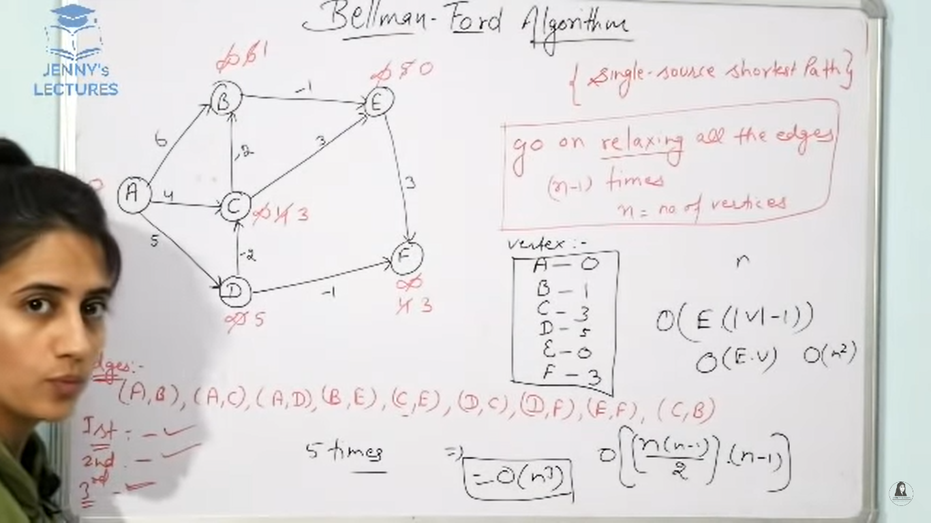

**Drawbacks of BellmanFord:**

* Bellman Fold algaritham will not work if graph contain any negitive wieght cycle .
* Negitive weight cycle means if a graph contains any cycle who’s edge sum is negitive.

Floyed wharshel Algorithem

Step1:First we need to prepair distance matrix for and we will denote it with D0.

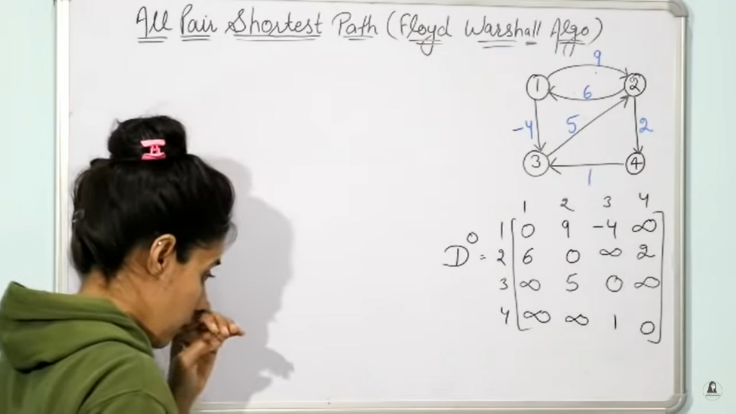

The above diagram is the initial distance .

Step2: Now we need to find out the distance bitween all the tags by consider Node 1 as middle element( like via in path).

Step3: We are name this Element as D1

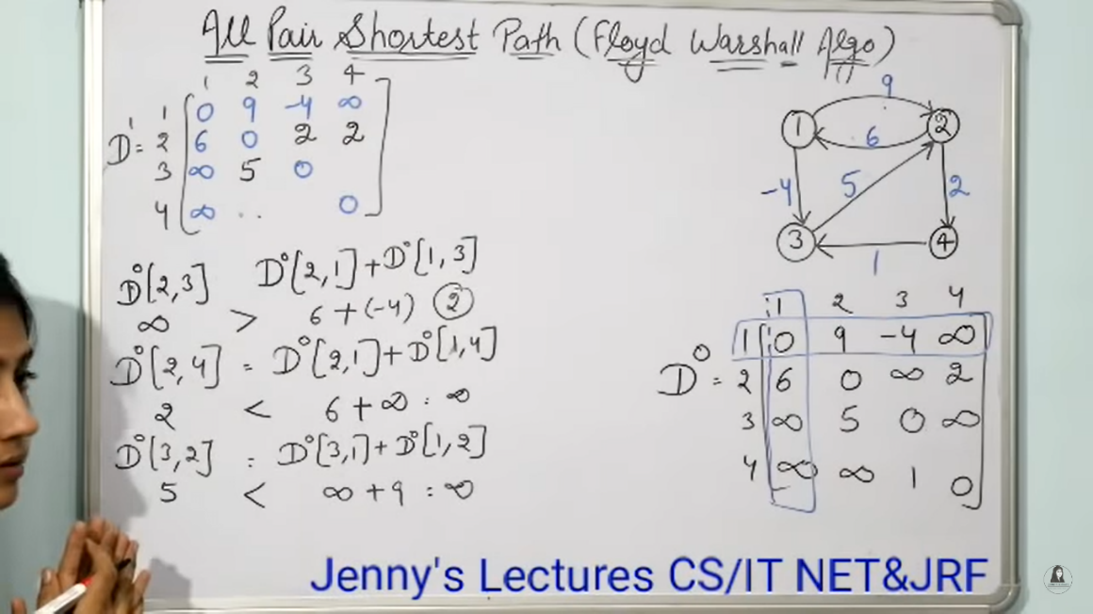

With same formula we need to fill all the remaining values in matrix.

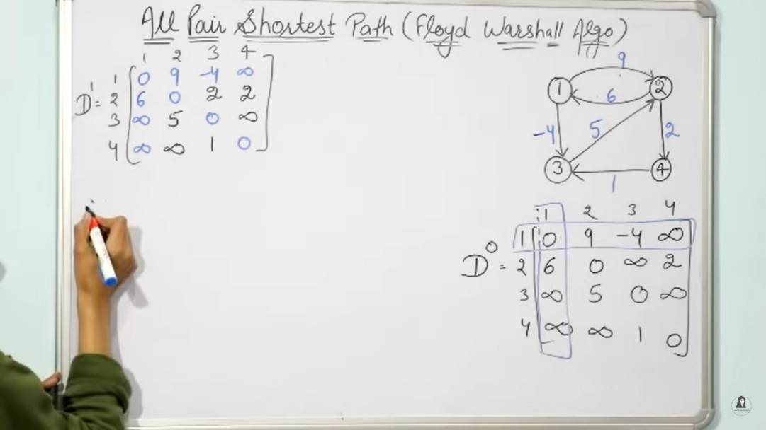

Now we need to calculate

Step4: Now we need to find out the distance bitween all the tags by consider Node 2 as middle element( like via in path).

Step5: We are name this Element as D2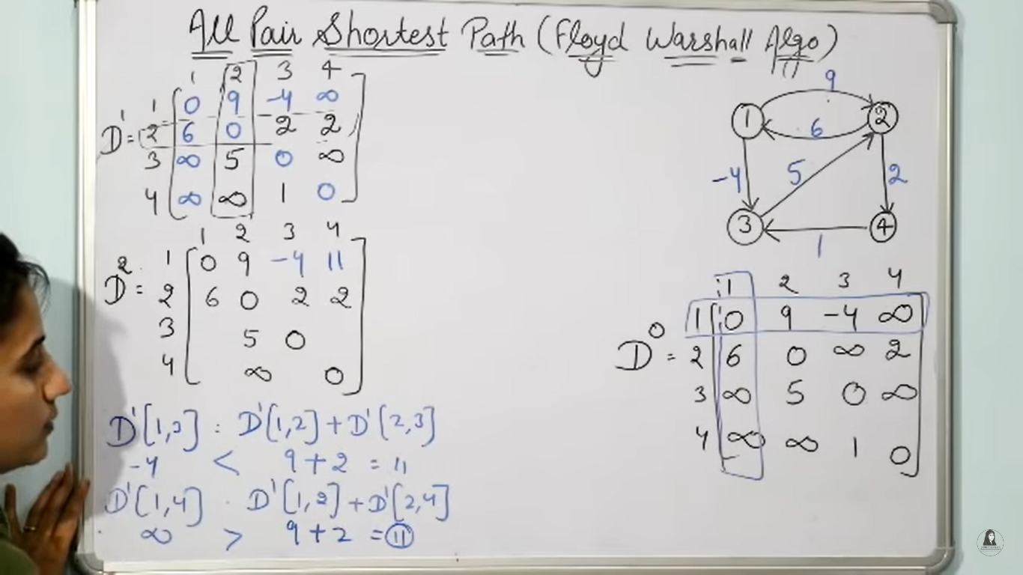

Like this we need to fill all the matrix values.

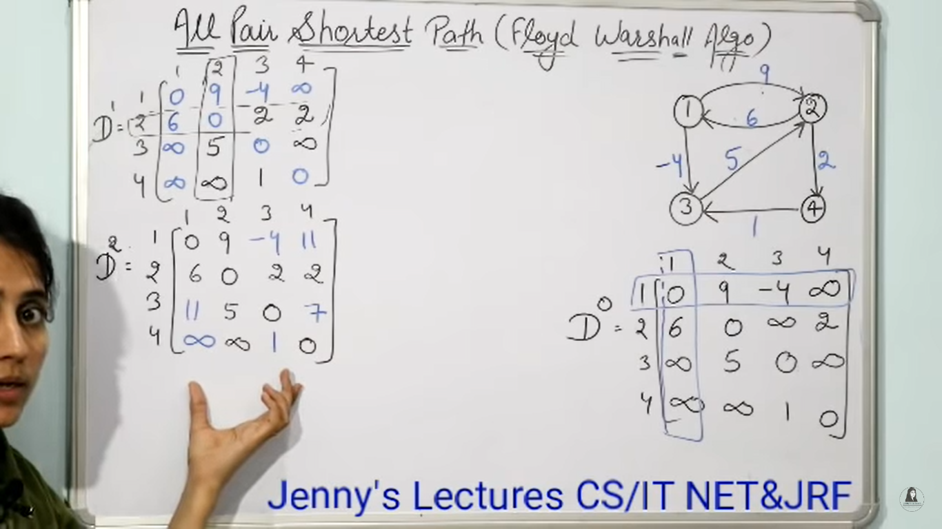

Step6: Now we need to find out the distance bitween all the tags by consider Node 3 as middle element( like via in path).

Step7: We are name this Element as D3

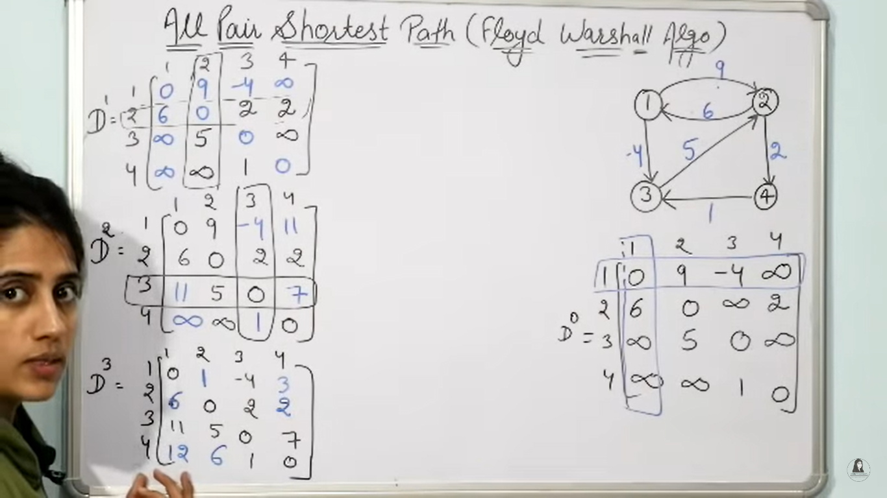

Step8: Now we need to find out the distance bitween all the tags by consider Node 4 as middle element( like via in path).

Step9: We are name this Element as D4

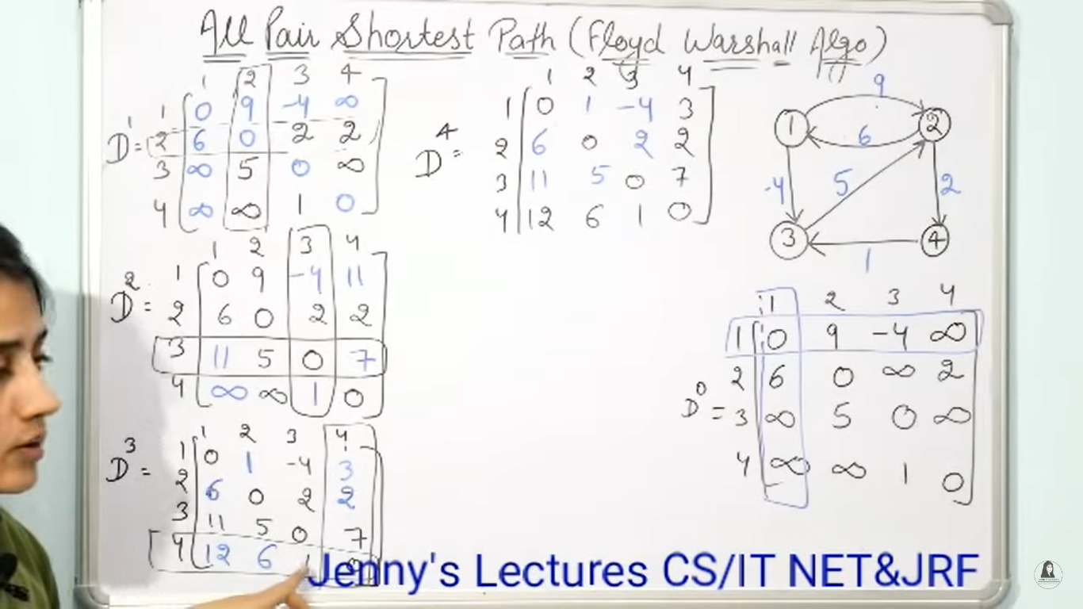

We need to use final Matrix to find the shortest distance i.e D4.

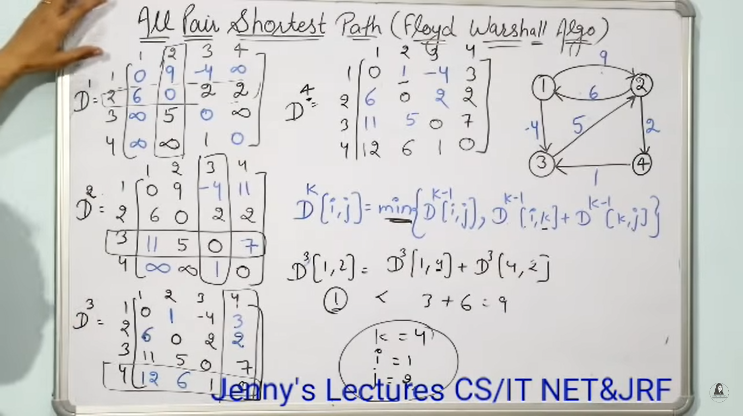

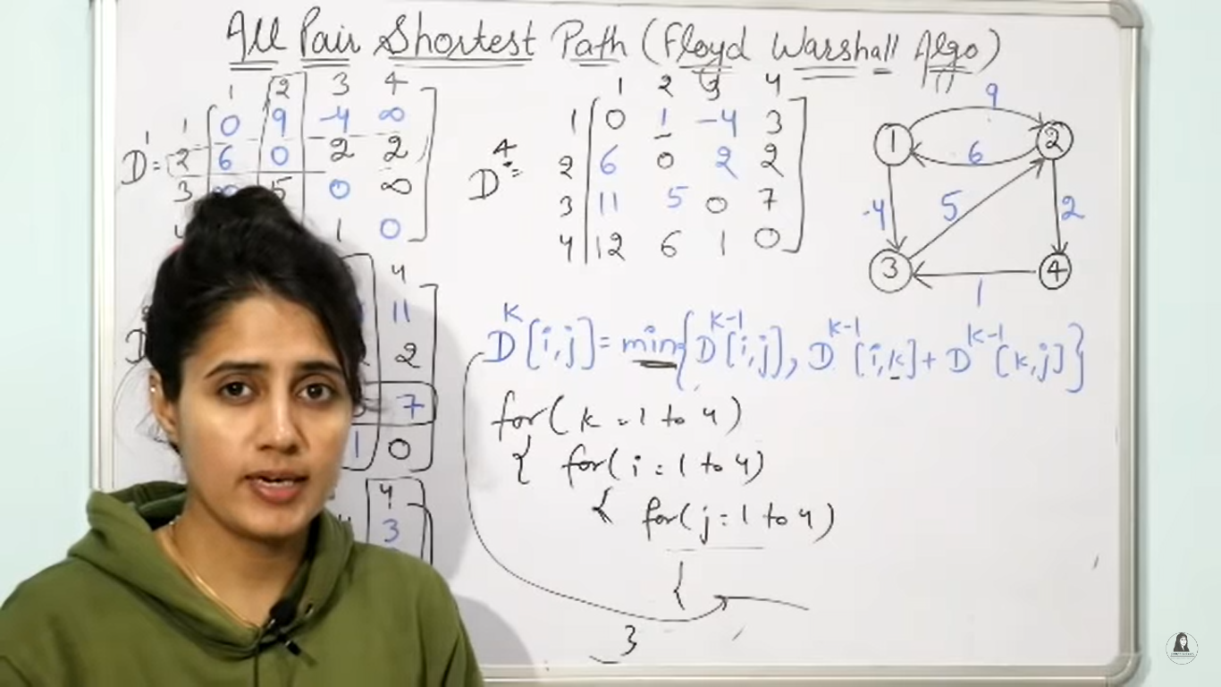

Linear Search Algorithem

* This is also known as sequential search algorithem
* In our Example we are considering 0 to 8 indexed array i.e n=8.
* For example we want to search data 42 in this array.
* So there are two cases

Bubble Sorting

**Principle**: The two adjecent elements are compared if those elements are in correct order then its fine we will move futher, if those elements are not in correct order, then we will swap these elements.

Here incorrect order means it depends on the order we want to sort like ascending or descending order, by default it is in ascending order.

Step1: we are going to start from first element, the first element is compared with secend element, if these are in incorrect order we are going to swap them.

Step2:Then next two adjecent elements are compared until we reach to the last index.

Ex:

15,16,6,8,5

Step1: first we need to compare 15 and 16 so they are in correct order ,no swapping is required.

Step2:now 16 and 6 are compared they are in incorect order. So we need to swap them.

15,6,16,8,5

Step3:Now 16 and 8 are compared so they are in incorect order , so we need to swap them.

15,6,8,16,5

Step4: Now we need to compare 16 and 5 so they are in incorrect order,so we need to swap them.

15,6,8,5,16

The complete above complete process is called one pass.

Here the largest element in this array is bubbled up to its right position.

So that’s why its known as bubble sort.

After this we need to do pass2 so the array is 15,6,8,5,16

Step2:

15, 6 , 8, 5, 16 --> 15 and 6 compared swapping done.

6, 15, 8, 5, 16 --> 15 and 8 are compared and swapping done.

6, 8, 15, 5, 16 -->15 and 5 are compared and swapping done.

6, 8, 5, 15 ,16 --> 15 and 16 are compared and no swapping done.

After this we need to do pass 3 the array is 6, 8, 5, 15, 16

Step3:

6, 8, 5, 15, 16 --> 6 and 8 compared no swapping done.

6, 5, 8, 15, 16 --> 8 and 5 compared swapping done.

6, 5, 8, 15, 16 --> 8 and 15 compared no swapping done.

6, 5, 8, 15, 16 --> 8 and 15 compared no swapping done.

After this we need to do pass 4 the array is 6,5,8,15,16

Step4:

6, 5, 8, 15, 16 --> 6 and 5 are compared and swapping done.

5, 6, 8, 15, 16 --> 6 and 8 are compared and no swapping done.

5, 6, 8, 15, 16 --> 8 and 15 are compared no swapping done.

5, 6, 8, 15, 16 --> 15 and 16 are compared no swapping done.

Ex:

for(i=0;i<n-1

{

"status": "success",

"code": 200,

"success": [

{

"bayId":"id1",

"bay": [

{

"subBayId":"id1",

"hint":"c1",

"ampshint":"12A",

"voltshint":"122V",

"lastamphint":"290A",

"lastVoltAmp":"68V"

},

{

"subBayId":"id2",

"hint":"c2",

"ampshint":"21A",

"voltshint":"40V",

"lastamphint":"78A",

"lastVoltAmp":"174V"

},

{

"subBayId":"id2",

"ampshint":"12A",

"hint":"c3",

"voltshint":"122V",

"lastamphint":"290A",

"lastVoltAmp":"68V"

}

]

},

{

"bayId":"id2",

"bay": [

{

"subBayId":"id3",

"ampshint":"16A",

"hint":"c4",

"voltshint":"17V",

"lastamphint":"18A",

"lastVoltAmp":"19V"

},

{

"subBayId":"id4",

"hint":"c5",

"ampshint":"21A",

"voltshint":"40V",

"lastamphint":"78A",

"lastVoltAmp":"174V"

}

]

}

]

}